# Presenters

# The inaugural Darwin Living Lab Symposium

Urban Design and Heat Mitigation in the Tropics

# 

Australia’s National  
Science Agency

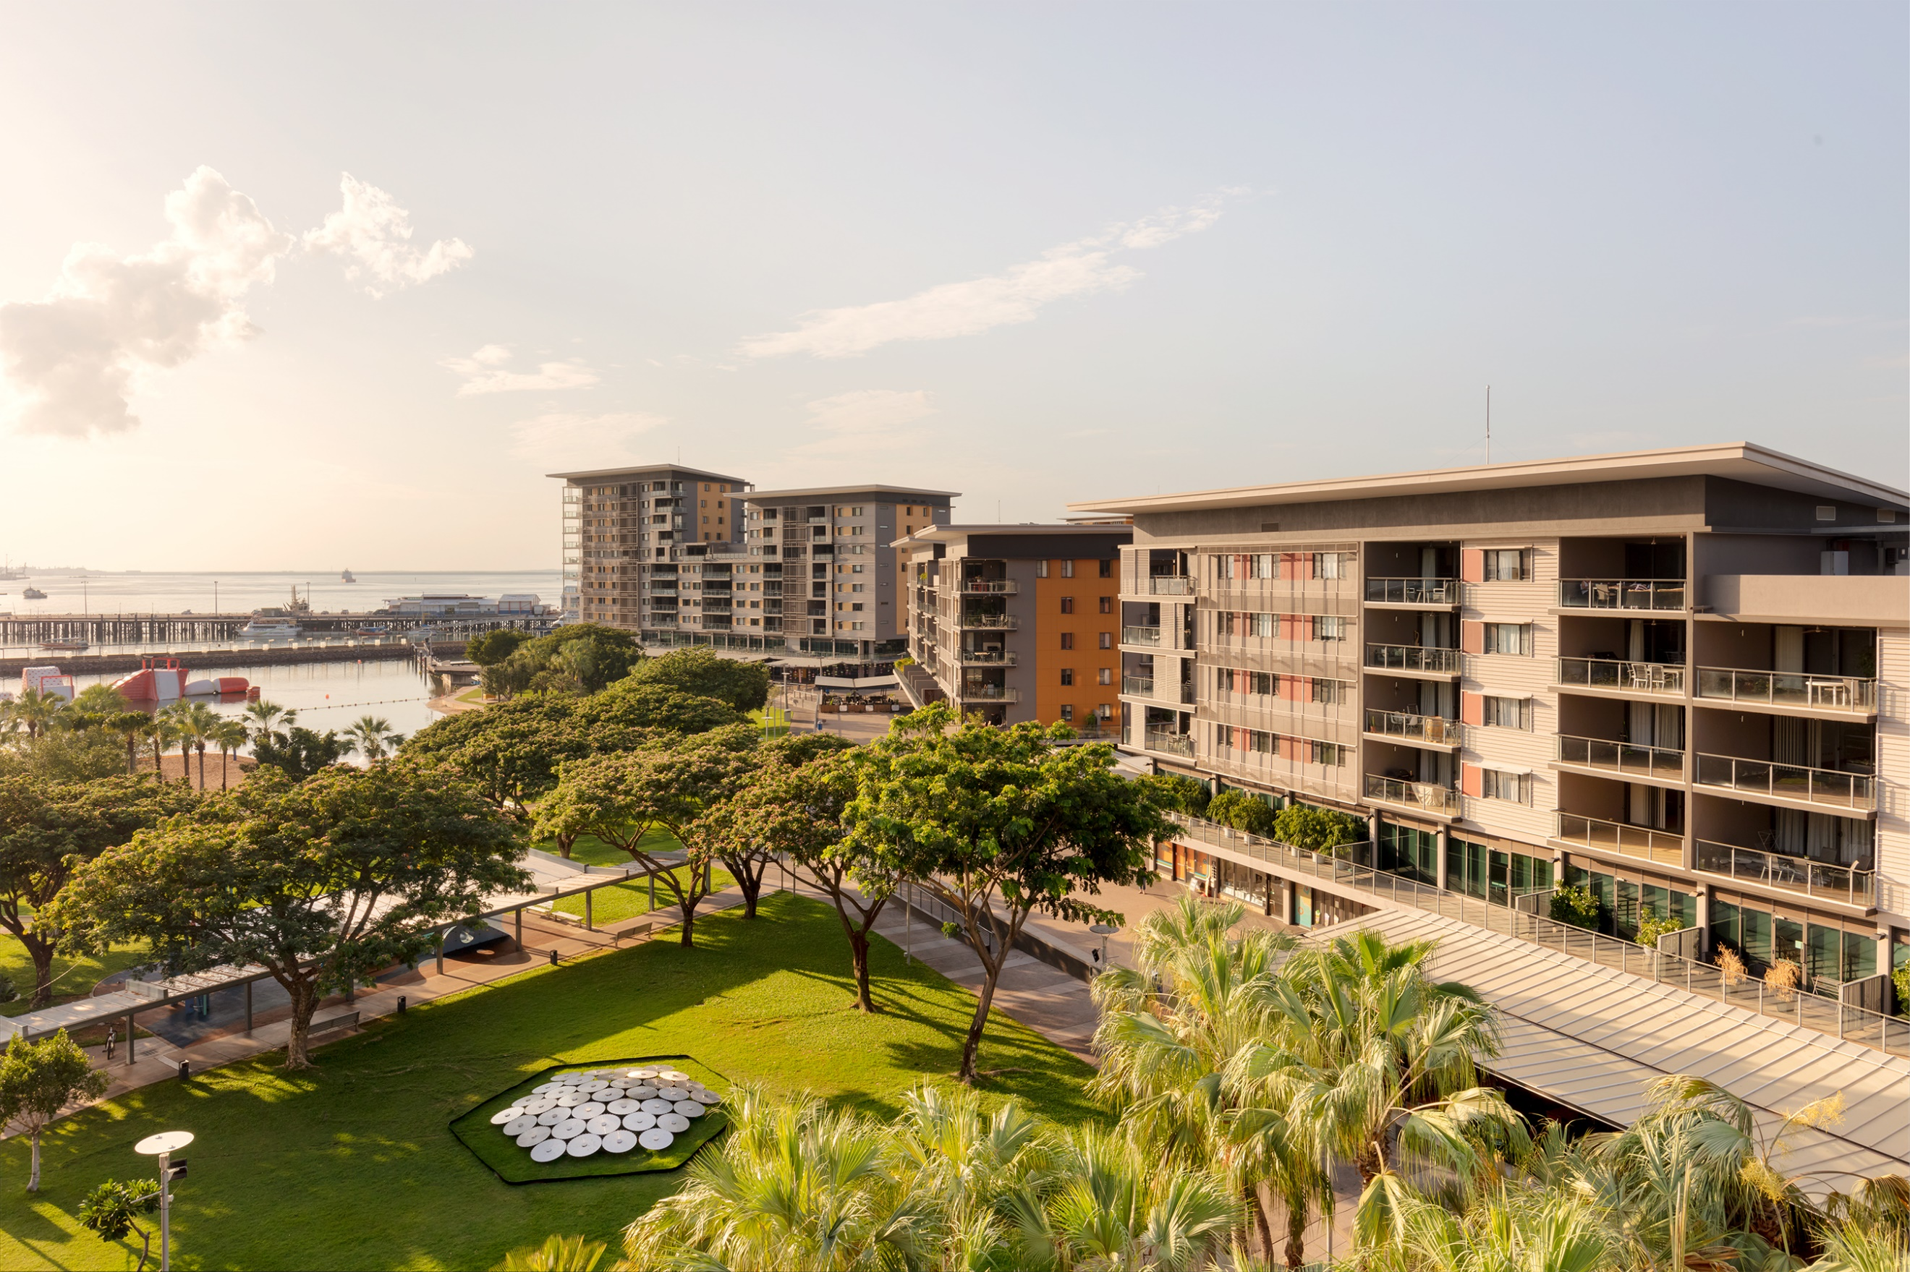

Contact us

1300 363 400

+61 3 9545 2176

csiroenquiries@csiro.au

csiro.au

As Australia’s national science agency   
and innovation catalyst, CSIRO is solving   
the greatest challenges through   
innovative science and technology.

CSIRO. Unlocking a better future for everyone.

## Duncan Challen

### General Manager, Business Development, Celestino, Sydney Science Park

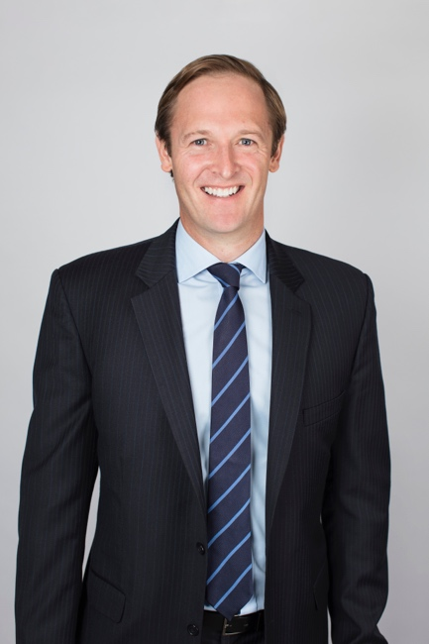

Duncan has proven international leadership leading diverse and complex businesses across multiple markets and countries in challenging business environments within the Private and Government sectors.

A global and future oriented leader with extensive international trade, industry and investment experience, having led the NSW Governments International Investment, Industry and Export organisations across 10 international markets, and significant multinational commercial expertise in building and managing sales and marketing businesses with for Shell across Asia Pacific, including having spent 3 years in China creating new Shell retail businesses with Chinese Joint Ventures across China.

Duncan has demonstrated successes in brokering collaborations between industry, government, universities, research institutions, start-ups and investors that create material and scalable commercial outcomes.

Duncan is now leading Celestino’s business development for the $5Billion Sydney Science Park greenfield development.

Contact us

1300 363 400

+61 3 9545 2176

csiroenquiries@csiro.au

csiro.au

As Australia’s national science agency   
and innovation catalyst, CSIRO is solving   
the greatest challenges through   
innovative science and technology.

CSIRO. Unlocking a better future for everyone.

## Gilbert Rochecouste

### Managing Director & Founder, Village Well

Gilbert Rochecouste Profile Picture


Gilbert is recognised locally and Internationally as a leading voice in Placemaking and the creation of vibrant, resilient and loved places. He is a sought after speaker and skilled facilitator for community and stakeholder engagement activities and has worked with over 1000 cities, towns, mainstreets and communities over the past 25 years. Gilbert co-founded the EPOCH Foundation promoting the adoption of business ethics. He has been on the boards of Ross House, Donkey Wheel House Trust and Hub Australia. Gilbert leads a multi-disciplinary team of Placemakers, researchers and designers.

### Project Highlights

* St Kilda Triangle Collaborative Design Process (Roots Projects Australia), 2015 – 2016.
* Longford Place Activation Plan (Northern Midlands Council), 2015.
* Jurien Bay Place Activation Community Engagement (Ardoss Group of Companies), 2015.
* Macquarie Point Place Vision and Activation Plan (Macquarie Point Development Corporation), 2014 – 2015.
* Monash University Place and Retail Vision (Monash University), 2014.
* Collins Court Place Story and Activation Concepts (Hobart City Council), 2014.
* ANU Community Engagement, Place Vision and Placemaking Strategy (ANU), 2014 – ongoing.
* Mathers Place Visioning (Hobart City Council), 2012.
* Rouse Hill Vision and Placemaking Strategy (GPT), 2005.
* Abbotsford Convent Vision, 1999.
* Flinders Lane & Degraves Street Activation and Place Vision, 1998.

Contact us

1300 363 400

+61 3 9545 2176

csiroenquiries@csiro.au

csiro.au

As Australia’s national science agency   
and innovation catalyst, CSIRO is solving   
the greatest challenges through   
innovative science and technology.

CSIRO. Unlocking a better future for everyone.

* Creation of the Queen Victoria Summer Night Markets, 1996.

As Australia’s national science agency   
and innovation catalyst, CSIRO is solving   
the greatest challenges through   
innovative science and technology.

CSIRO. Unlocking a better future for everyone.

Contact us

1300 363 400

+61 3 9545 2176

csiroenquiries@csiro.au

csiro.au

## Mat Santamouris

### Scientia Professor, School of Built Environment

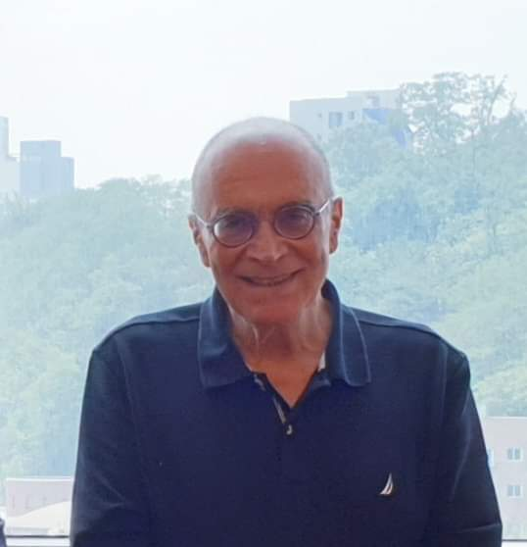

M. Santamouris is a Scientia Professor of High Performance Architecture at UNSW, and past Professor in the University of Athens, Greece. Visiting Professor: Cyprus Institute, Metropolitan University London, Tokyo Polytechnic University, Bolzano University, Brunnel University and National University of Singapore. Past President of the National Center of Renewable and Energy Savings of Greece. Editor in Chief of the Energy and Buildings Journal, Past Editor in Chief of the Advances Building Energy Research, Associate Editor of the Solar Energy Journal and Member of the Editorial Board of 14 Journals. Editor of the Series of Books on Buildings, published by Earthscan Science Publishers. Editor and author of 14 international books published by Elsevier, Earthscan, Springer, etc. Author of 320 scientific articles published in journals. Reviewer of research projects in 29 countries including USA, UK, France, Germany, Canada, Sweden, etc.

### Recent Publications

* Junsong Wang, Qinglin Meng, Lei Zhang, Yu Zhang, Bao-Jie He, Senlin Zheng, Mat Santamouris : Impacts of the water absorption capability on the evaporative cooling effect of previous paving materials, Building and Environment (2019), doi: <https://doi.org/10.1016/j.buildenv.2019.01.033>.
* Gihan Samarasinghe, Malgorzata Lagisz, Mattheos Santamouris, Komali Yenneti, Anir Kumar Upadgyay, Faustino De La Peña Suarez, Bhavesh Taunk, Shinichi Nakagawa : A visualized overview of systematic reviews and meta-analyses on low-carbon built environments: An evidence review map. Solar Energy 2019.
* 307 | Ilias Agathangelidis, Constantinos Catalis and Mat Santamouris : Integrating Urban Form, Function, and Energy Fluxes in Heat Exposure Indicator in View of Intra-Urban Heat Island Assessment and Climate Change Adaptation 208, Climate 2019, 7, 75; doi:10.3390/cli7060075.
* Prashant Anand, David Cheong, Chandra Sekhar, Mattheos Santamouris, Sekhar Kondepudi, Energy saving estimation for plug and lighting load using occupancy analysis, (2019), doi:10.1016/j.renene.2019.05.08.
* S.Karatasou and M.Santamouris : Socio-economic status and residential energy consumption: a latent variable approach. Energy and Buildings, Volume 198, 1 September 2019, Pages 100 – 105.
* Andri Pyrgou, Mattheos Santamouris and Iro Livada : Spatiotemporal Analysis of Diurnal Temperature Range: Effect of Urbanisation, Cloud Cover, Solar Radiation, and Precipitation, Climate 2019, 7, 89; doi:10.3390/cli7070089.

## Tony Cox

### Director, Clouston Associates

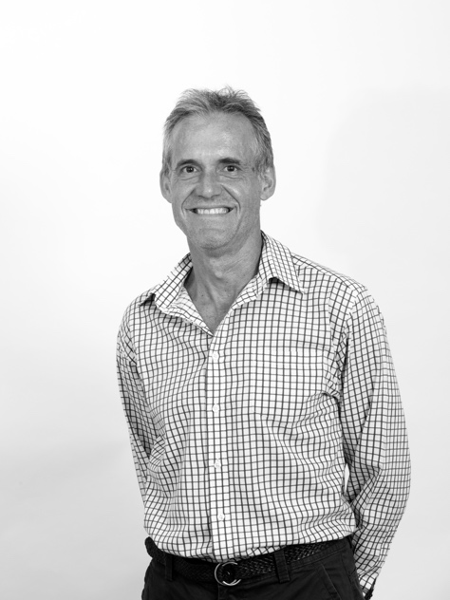

Tony Cox is a Director of CLOUSTON Associates, having been a practicing Landscape Architect since 1986. Before joining CLOUSTON Associates in 1992, his professional career included experience in the public sector, large multi-disciplinary practices and as a sole practitioner. This has seen him conduct work in Sydney, Perth, Brisbane and England. He has been the Manager of CLOUSTON Associates in the Northern Territory since 1993.

Within CLOUSTON Associates, Tony has played a central role in a diverse range of planning, masterplanning and tourism projects undertaken across northern Australia, central Australia and South East Asia. His specialist expertise lies in his ability to draw out the core principles and distinguishing characteristics of any planning and design project. He brings to every project a planning/design ethos based on local ‘language’ and design integrity matched with the best practise environmental outcomes.

His ability to produce robust, inspirational documents is evident in the many awards afforded to CLOUSTON Associates and our clients. Most recently, the office has received design awards and a national sustainability award for its work on the Darwin International Airport and DEC/ Holiday Inn Forecourt. Often these awards and recognitions have been the result of intensive consultation that has effectively focussed community support and active participation.

Tony continues to be an active member of AILA at both territory and national levels. He has been a member of the AILA (NT) executive since 1992, including eight years as President. He is a past National President and was Chair of the Community and Environment Committee for 4 years. More recently, he has been a member of the NT Government Architects Expert Advisory Committee and was an expert panel member of Darwin City Tree Replacement Advisory Committee following the devastation of Cyclone Marcus.

### Awards, Papers and Publications

* ‘Greening & Cooling the City’ - Initial heat mitigation paper prepared for NTG and City of Darwin, 2016
* ‘Communities for Living’ - Developing Northern Australia Conference, 2016
* ‘Alice Outcomes’ - My Park Rules National Competition (Special Jury Award), 2016

### Selected Experience

* Darwin CBD Heat Mitigation and Landscape - Brief development, master planning and presentation drawings in conjunction with Government Architect
* Darwin CBD Streets Greening & Cooling The City - Masterplanning report for council & NTG
* Cavenagh Street Stages 1 & 2 - Street upgrades for greening & heat mitigation
* Bicentennial Park - Masterplan, implementation strategy and project briefs
* Maluka Views – Master Plan, Urban Design Guidelines and Public Realm Design
* Palmerston CBD Upgrades - Streetscape upgrades for pedestrians, cyclists and shade
* Darwin CBD Urban Forest - Issues, opportunities and feasibility of creating an urban forest
* Garramilla Boulevard - Masterplan, design and documentation of an innovative tropical urban boulevard as a new benchmark in street design and public amenity

## Roger Mainwood

### Principal/Director/Associate Professor, JCU Urban Planning

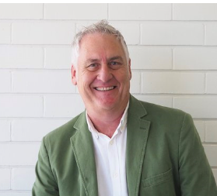

Roger is a registered Architect and Principal Director of TPG Architects. Roger has unique experience in the ability to adapt needs of projects to their particular sites. He has had extensive involvement in the Cairns CBD masterplan, initially as a consultant in 2007 and led its review in 2018-19. Roger was Project Manager and Architect for the conversion of the Tanks Community Arts Centre, School of Arts and Cairns Museum. Roger has received numerous State and National Architectural and heritage awards including recently for the Cairns School Of Arts Museum and the Trinity Inlet precinct master plan incorporating conversion of Wharf Shed 3 into the Cairns Cruise Liner Terminal. His expertise in tropical design is evidenced by his award winning residential and commercial projects including the regional AIA House of the Year for Struthers Residence, Port Douglas. Roger’s close involvement with community groups always ensures his concepts are sensitive to the needs of users.

### Papers and Conferences

* ‘Tropical Building design, residential and commercial responses’. Guest lecturer JCU Urban Design Winter school studio, 2012- 2015
* Joint convenor of the establishment of the AIA triennale QLD Regional Conference programme, the first held in Cairns 2013 ‘Spirit of Place’, where also a presenter, Townsville 2016 ‘Evoke’ and again In Cairns 2019 ‘Connecting Narratives’.
* Joint Convener of the AIA Regional Conference, ‘On Edge, Off Centre’ Cairns 2005
* ‘Tropical Building Design and the Building Act, at odds’ the Australian Institute of Building Surveyors 13th National Conference 1990.

### Key Project Experience

* COCA, centre of contemporary art redevelopment, Cairns, 2019
* JCU Catholic College Masterplan, 2019
* Freshwater College Masterplan, Cairns, 2019
* School of Arts Cairns Museum, Cairns, 2017
* Tanks Community Arts Centre, Cairns, 1994- 2017
* Cairns Cruise Liner Terminal and Trinity Inlet Masterplan, Cairns, 2012

As Australia’s national science agency   
and innovation catalyst, CSIRO is solving   
the greatest challenges through   
innovative science and technology.

CSIRO. Unlocking a better future for everyone.

Contact us

1300 363 400

+61 3 9545 2176

csiroenquiries@csiro.au

csiro.au

## Yeong Zee Kin

### Assistant Chief Executive (Data Innovation and Protection Group), Infocomm Media Development Authority of Singapore; Deputy Commissioner, Personal Data Protection Commission

Yeong Zee Kin is the Assistant Chief Executive (Data Innovation and Protection Group) of the Infocomm Media Development Authority of Singapore (IMDA) and Deputy Commissioner of the Personal Data Protection Commission (PDPC).

In his capacity as ACE (Data Innovation and Protection Group), Zee Kin oversees IMDA’s Artificial Intelligence and Data Industry development strategy. This is one of four frontier technology areas IMDA has identified for its transformational potential for a Digital Economy. The other three are cybersecurity, the Internet of Things, and immersive media. In his role as an AI and data analytics champion, Zee Kin’s work includes developing forward-thinking governance on AI and data, driving a pipeline of AI talent, promoting industry adoption of AI and data analytics, as well as building specific AI and data science capabilities in Singapore.

As the Deputy Commissioner of PDPC, Zee Kin oversees the administering and enforcement of Singapore’s Personal Data Protection Act 2012. His key responsibilities include managing the formulation and implementation of policies relating to the protection of personal data, as well as the issuing of enforcement directions for organisational actions. He also spearheads public and sector-specific educational and outreach activities to raise both awareness and compliance in organisations and individuals in personal data protection.

As Australia’s national science agency   
and innovation catalyst, CSIRO is solving   
the greatest challenges through   
innovative science and technology.

CSIRO. Unlocking a better future for everyone.

Contact us

1300 363 400

+61 3 9545 2176

csiroenquiries@csiro.au

csiro.au

## Jo Cruickshank

### Senior Policy Officer – Strategy, Policy and Legislation

### Department of Infrastructure, Planning and Logistics

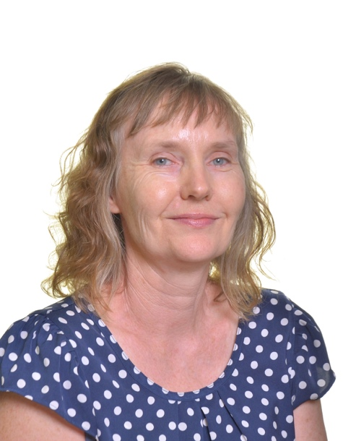

Jo is a Senior Policy Officer with the NT Department of Infrastructure, Planning and Logistics and her work focusses on active and sustainable transport.

Jo is passionate about the potential for cycling and walking to create more liveable and connected communities and delivering the infrastructure, policies and programs to encourage people to choose active transport for short trips and daily commutes.

Jo has over 20 years’ experience working in transport and land use planning and has previously worked for the NSW Roads and Traffic Authority and the NSW Department of Planning. In 2017 Jo was awarded a Churchill Fellowship to study cycling policies and programs in regional cities in the UK and Europe.

As Australia’s national science agency   
and innovation catalyst, CSIRO is solving   
the greatest challenges through   
innovative science and technology.

CSIRO. Unlocking a better future for everyone.

Contact us

1300 363 400

+61 3 9545 2176

csiroenquiries@csiro.au

csiro.au

## Dr Tim Muster

### Principal Research Scientist

### Director of CSIRO Urban Living Labs and Team Leader, Adaptive Liveable Cities

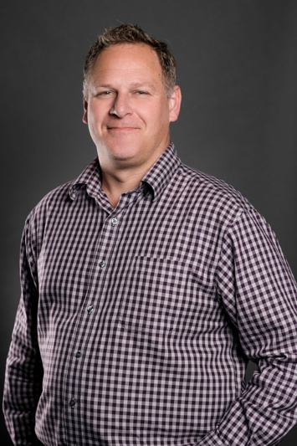

Dr Muster has a background in integrated technology options for cities such as urban water and waste systems, energy and nutrient recovery from wastewater, urban agroecosystems, resource efficiency and embedded sensing technologies for infrastructure. He oversees CSIRO’s Urban Living Labs program which seeks place-based urban transformations in CSIRO’s work programs in Darwin, Western Sydney and the A.C.T.  Dr Muster has published over 75 peer-reviewed scientific papers in various fields including pharmaceuticals, mining, aerospace, agriculture, environmental, water and urban domains; giving him a broad perspective of system interdependencies and the need for multidisciplinary research to achieve effective change toward more liveable, sustainable and resilient cities.

## Ms Seona Meharg

### Senior Experimental Scientist, CSIRO

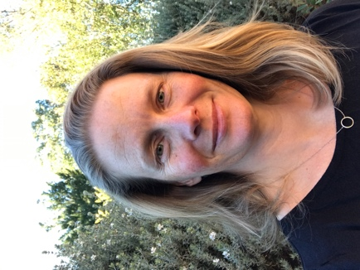

As Australia’s national science agency   
and innovation catalyst, CSIRO is solving   
the greatest challenges through   
innovative science and technology.

CSIRO. Unlocking a better future for everyone.

Seona Meharg is an integration scientist who exploring the theory and practice of transdisciplinary approaches to complex adaptation projects in Australia and the Asia-Pacific region. One area of focus is how to improve individual and collective learning for adaptive decision making, in particular understanding the capacities, competencies and networks of change agents, and how these can be cultivated in others to achieve positive systemic change.

Contact us

1300 363 400

+61 3 9545 2176

csiroenquiries@csiro.au

csiro.au

## Dr Brenda Lin

### Research Scientist, CSIRO



Dr. Lin has been with CSIRO since 2010, and currently situated in the Adaptable Liveable Cities team in Land & Water. Prior to joining CSIRO, Dr Lin was a Science & Technology Policy Fellow with the American Association for the Advancement of Science in Washington DC, USA. During this time she worked for the United Stated Environmental Protection Agency within the Global Change Research Program in the Office of Research and Development. Her research at the US EPA focused on climate change impacts within the natural and built environment and examined potential climate change adaptation strategies at the national scale.

Dr. Brenda Lin’s research examines how natural systems or components of natural systems can be maintained or integrated into an increasingly developed landscape to provide ecosystem services that optimize both environmental and human well-being.  One specific focus has been to study changes in vegetation within urban systems and its effect on projected climate change impacts in cities and on human health. Dr. Lin’s work is inherently interdisciplinary in nature, as the interactions between humans and their environment are complex to manage. Much of the research is highly applied with the hope that the research will inform on future public policy and help create resilient socio-ecological systems.

## Rachel Williams

### Social Scientist, CSIRO

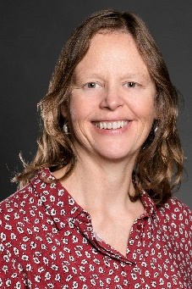

Rachel Williams is a senior social scientist in CSIRO Land & Water, based in Canberra. Rachel has twelve years experience working with regional communities and with all levels of government combining research and evaluation approaches to understand how scientists and communities can learn to work together to enable effective adaptation. Most of her work has been with regional communities, in areas such as sustainable development, adapting to coal seam gas development, climate change adaptation and urban sustainability planning. The range of approaches she draws on in her work include evaluation, as a means of facilitating learning among project participants and to derive insights from across multiple case studies, participatory research, social learning and visual methods. She brings a strong interdisciplinary perspective to her work from her own background in both biophysical and social science.

## Josh Sattler

### General Manager Innovation, Growth and Development Services

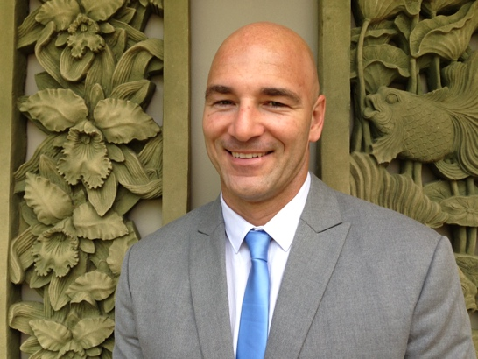

Responsible for shaping the future of the City of Darwin through planning and delivery of growth and development opportunities that incorporate Smart Cities’ philosophies, digital transformation, economic and tourism development opportunities, climate change, international relations, resilience and environmental improvement opportunities.

A dedicated global strategist, Josh Sattler is an accomplished driver of economic development in destinations across Asia Pacific, the Middle East and the America. He has managed large global projects and operations as well as community engagement programs with impressive triple bottom-line success across multiple international accreditation platforms and frameworks.   
Based on the Gold Coast since 1998, Josh is the “go-to” international executive with extensive global experience across government and private enterprise.   
A globally recognised and experienced professional with many successful international partnerships developed and initiated. Focused on delivering performance in organisation and community in over 23 different countries. Josh is a sought after professional experienced in change management across multiple destinations. A critical enabler to this success is the embedding of triple bottom line performance, a metric Josh is very well accustomed to detail, report and improve upon for all potential clients and future employers.   
Josh holds qualifications in Environmental Science, Economics and Sustainability including supply chain management from Swinburne University, Melbourne Australia.

As Australia’s national science agency   
and innovation catalyst, CSIRO is solving   
the greatest challenges through   
innovative science and technology.

CSIRO. Unlocking a better future for everyone.

Contact us

1300 363 400

+61 3 9545 2176

csiroenquiries@csiro.au

csiro.au

## Guy Barnett

### Future Cities Coordinator and Principal Research Consultant, CSIRO

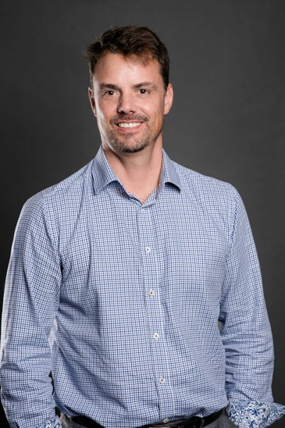

Guy Barnett is an Urban Ecologist with the Commonwealth Scientific and Industrial Research Organisation (CSIRO) based in Canberra.  He joined CSIRO almost 25 years ago and since then has worked on issues from the restoration of degraded landscapes; to how we adapt our cities to the impacts of climate change; to living labs as collaborations to de-risk and accelerate urban innovation.  Guy is currently the Coordinator of the Future Cities initiative in CSIRO, where he works to integrate cities-related research from across the organisation.  He is also an active member of several international urban research networks including the Resilience Alliance and Stockholm Resilience Centre.

## Tracey Duldig

### Principal Policy Officer - Economic and Environment Policy

### Department of the Chief Minister

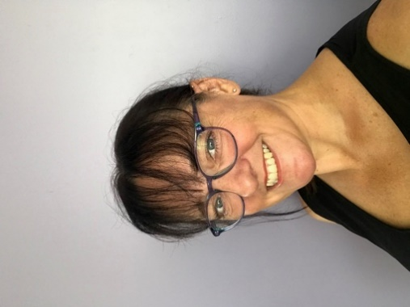

Tracey Duldig has over 15 years’ experience working in environmental policy and wildlife regulation fields and was instrumental in introducing the NT’s Container Deposit Scheme. Tracey is currently the Principal Policy Officer within the Economic and Environment Unit at the Department of the Chief Minister. Apart from working on the heat mitigation strategy, Tracey has most recently been working on both climate change and offset policies.

As Australia’s national science agency   
and innovation catalyst, CSIRO is solving   
the greatest challenges through   
innovative science and technology.

CSIRO. Unlocking a better future for everyone.

Contact us

1300 363 400

+61 3 9545 2176

csiroenquiries@csiro.au

csiro.au