Conference Program

Tuesday, 16th November (AEST)
Session 1| Master Class: Food and Health
Chairs: Alejandra Acevedo-Fani & Amy Logan
7:00am -9:30am (AEDT)
7:00-7:40am | Topic 1: Food, Nutrition & Sustainability  - Dist. Professor Paul J. Moughan, Riddet Institute Fellow Laureate, Riddet Institute, Massey University, New Zealand  Title: Food, Nutrition and Sustainability  - Professor Manny Noakes, Nutrition Consultant & Meat & Livestock Australia Board Director, Australia  Title: Impact of Food Structure on Health
7:40-8:15am | Topic 2: in vitro/in vivo Models of Digestion  - Dr Diddier Dupont, Deputy Director of STLO (Science & Technology of Milk & Egg), INRAE, France  Title: Static and dynamic in vitro digestion models: what’s new?  - Dr Simone Osborne, Senior Research Scientist, CSIRO Agriculture & Food, Australia  Title: Combining in vitro digestions with intestinal cell models: Challenges and insights
8:15-8:55am | Topic 3: Food Structure & Digestion  - Professor Matt Golding, Professor in Food Colloids, Massey University, New Zealand  Title: Relating food composition to nutritional and physiological value – why food structure matters, and why it doesn’t  - Professor Mike Gidley, Centre Director, Centre for Nutrition & Food Science, University of Queensland, Australia  Title: Unpicking dietary guidelines – roles for plant-based food structures
8:55- 9:30am | Topic 4: Computational (in-silico) Models of Digestion:  - Dr Matt Sinnott, Senior Research Scientists, CSIRO Data61, Australia  Title: Modelling human digestive physiology for smarter food design  - Prof Leo Cheng, Bioengineering Institute, The University of Auckland, New Zealand  Title: Experimental and Mathematical Modelling Techniques for Quantifying Gastric Motility Patterns

Wednesday, 17th November 7:00am-9:30am (AEDT)
7:00-7:02am | Introductions  Dr Cuong Tran, Team Leader/Senior Research Scientist, CSIRO Health & Biosecurity, Australia
7:02-7:06am | Welcome to country ceremony  Michael O'Brien, South Australian Indigenous Kaurna Elder
7:06- 7:10am | Opening remarks:  Dr Leif Lundin, Research Director, Food Program, CSIRO Agriculture & Food, Australia
Session 2 | Food Structure Design, Processing and Digestion
Chairs: Mike Gidley & Anant Dave
7:10am – 9:00 AEDT
7:10-7:35am | Dr Gail Bornhorst, University of California Davis, USA  Title: Linking Food Processing and Structure to Food Breakdown during Digestion: The Case of Carbohydrate-Based Foods.
7:35-8:00am | Dr Cathrina Edwards, Quadram Institute Biosciences, UK  Title: Pulses, plant cells and nutrition
8:00-9:00am | Free papers  - Adam Macierzanka, Assoc Prof, Gdansk University of Technology, Poland  Title: Substituting human bile with bile salt/phosphatidylcholine mixtures for physiologically-relevant gastrointestinal proteolysis and lipolysis studies  - Ruoxuan Deng , PhD candidate, Wageningen University  Title: Monitoring gastric digestion of protein gels by MRI: A randomized clinical trial  - Dr. Marta Martínez Sanz, Research Scientist  Instituto de Investigación en Ciencias de la Alimentación, Spain  Title: Development of novel polysaccharide-casein gel-like structures resistant to gastric digestion  - Martina Moretton, PhD Student, University of Udine, Italy  Title Comparison between adult and elderly in vitro digestibility patterns of proteins and carbohydrates as affected by different bread types
9:00-9:30am | Interactive Poster sessions  - Daria Zelikina, Early Career Researcher, Institute of Biochemical Physics, Russia  Simulated digestion of the complex based on WPI, chitosan, and bioactive lipids: structure and thermodynamic characteristics  - Ali Rashidinejad, Riddet Institute, Massey University, NZ  The effect of protein type on the properties of flavonoid-protein co-precipitates for their delivery in food products  - Aarti Tobin, Early Career Researcher, CSIRO Australia  Improved texture modified foods for aged care: from design to consumer testing  - Aleksandra Florczuk, PhD student, University of Warmia and Mazury, Olsztyn, Poland  The effect of beta-glucans on milk protein digestibility in yogurt  - Abhilasha Abhilasha, Phd student, Riddet Institute, Massey University, NZ  Does Hydrothermal Treatment and Low-Temperature Storage of Whole  Wheat Grains In Situ Affect the In Vitro Starch Hydrolysis and Flour  Properties?  - Adam Fitzgerald, CSIRO Australia  In vitro digestibility of novel biphasic beef powder/alginate gel foods and the implications for the bio accessibility of the essential nutrients iron and zinc.  - Alex Kanon, Phd student, Riddet Institute, Massey University, NZ  Can eating a kiwifruit in the evening improve sleep and mood?  - Boning Mao, Phd student, Riddet Institute, Massey University, NZ  Plant-based meat. Understanding the Mechanisms of Fibre  Formation by Plant Proteins during Thermomechanical Processing (TMP)  - Bulei Sheng, PhD student, Aarhus University, Denmark  influence of κ-casein heterogeneity on its in vitro gastrointestinal digestion  - Dalila Roupar, PhD student, University of Minho, Portugal  Human gut microbiota fermentation of microbial-fructooligosaccharides  - Daniel Madalena, PhD student, University of Minho, Portugal  Development of a reproducible, automated, realistic in vitro gastric model  - Davood Zaeim, PhD Student, Zhejiang Gongshang University, China  Effect of alginate, pectin and guar gum on the in vitro gastric emptying pattern of soymilk  - H.N Nadeesha Dilrukshi, PhD student, Lincoln University, Canterbury, New Zealand  Effects of extrusion processing on the bioactive constituents, and antioxidant potential of novel gluten-free extruded snacks fortified with cowpea and whey protein concentrate  - Stephen Giteru et al, AgResearch Limited, Palmerston North, New Zealand.  Quinoa Protein: Extraction and Functionality

Thursday, 18th November 7:00am-9:00am (AEDT)
Session 3 | Food, Microbiome and Health
Chairs: Michael Conlon & Cuong Tran
7:00am -9:30am (AEDT)

7:00-7:30am | Professor Colin Hill, University College Cork, Ireland  Title: You have the microbiome you (and your diet) deserve!
7:30-8:00 | Professor Sven Petterson, Nanyang Technological University, Singapore  Title: Promoting healthy ageing and delayed onset of neurodegenerative diseases by food intervention strategies targeting gut microbes.  Free papers
8:00-9:00 | - Cindy Bermúdez, PhD Candidate, The University of Queensland, Australia  Title: Microbial community dynamics as nut particles breakdown during in vitro porcine faecal fermentation  - Professor Yoav D. Liveny, Israel Institute of Technology, Israel  Title: Oligosaccharide-lactoferrin conjugate particles for selective targeting of proteins to probiotic bacteria in the colon  - Shouryadipta Ghosh, Early Research Career Fellow, CSIRO Data61  Title: A coupled biomechanical-sph model to investigate emptying of mixed solid and liquid content from the stomach  - Dr Siqi Li, Postdoctoral Fellow, Riddet Institute, Massey University  Title: Dynamic in vitro gastric digestion behaviour of sheep, goat and cow milk: effects of processing and species
9:00-9:30: | Interactive Poster session
- Giavanna Castillo, PhD student, Riddet Institute, Massey University, NZ
In vitro simulation of lipid digestion, absorption, and post-prandial activity
- Hong Yao, PhD student, The University of Queensland, Australia
Particle size: an important functional property affecting fermentability of commonly consumed dietary fibres
- Jaqueline Nadolny, PhD student, University of Queensland, Australia
Bunya nut as a healthy and versatile gluten-free flour
- João Araújo, PhD student, University of Minho, Portugal
Physicochemical characterisation and cell viability of riboflavin loaded WPI
nanostructures towards foods fortification
- Juan Molina Ortiz, PhD student, University of Sydney, Australia
From gut microbiome strains to metabolic networks: a key step for
the design of health-promoting, rational dietary interventions
- Kevion Darmawan, PhD student, RMIT, Australia
The application of novel computational approaches to understand the gastricdigestion of a whey protein complex: apo-lactoferrin, β-lactoglobulin, and α-lactalbumin
- Linda Nezbedova, PhD student, Massey University, NZ
An investigation into the phytochemical profile of ‘Monty’s Surprise’ heritage apple and the effect of simple household processing techniques on its phytochemical composition
- Manuel Martinez, PhD student, Universidad Autónoma de Madrid, Spain
Egg white hydrolysate based- ice cream as a functional alternative to dairy-based ice cream
- Maria Roca, Early Career Researcher, Instituto de la Grasa (CSIC), Spain
What Governs the In Vitro Digestion of Chlorophylls?
- Mariero Gawat, Phd student, Riddet Institute, Massey University, NZ
Effect of microwave-induced thermal processing on the quality and structure of goat and lamb meat
- Mengxiao Yang, Phd student, Riddet Institute, Massey University, NZ
- Renata Ariens, Wageningen, The Netherlands
Comparing nutritional and digestibility aspects of sustainable proteins using the INFOGEST digestion protocol
- Taciana Lunelli, Phd student, Riddet Institute, Massey University, NZ
Milk fat globule membrane stabilised emulsions to deliver curcumin to the brain
- Athirojthanakil Weetachich et al, Riddet Institute, Massey University, NZ
Liposomal encapsulation of green tea waste catechins and the effect on physicochemical and structural properties of fresh green kiwifruit juice

Friday, 19th November 7:00am-9:30am (AEDT)
Session 4: Future Challenges and Research - Food Evolution vs Revolution
Chairs: Ingrid Appelqvist & Harjinder Singh
7:00am -9:35am (AEDT)

7:00-7:20 | Nick Hazel, CEO & Founder, v2food Pty Ltd, Australia
7:20-7:40 | Dr Brendan Haigh, General Manager – Innovation Miraka, New Zealand  Title: Designing Food for a More Sustainable Future
7:40-8:10 | Company Creations Panel Discussion – Ideas to Commercialisation  - Penny Brereton, CEO & Senior Consultant, TSM Advisory Pty Ltd, Board Member, NutriV Pty Ltd, Australia  - Gabrielle Munzer, Deep Tech Venture Capital Investor, Main Sequence Ventures, Australia
8:10-9:00 | Free papers  - Ms Li Ming Lim (Kezlyn Lim), Research Dietician, Singapore Institute for Clinical Sciences, Agency for Science, Technology and Research (A*STAR)  Title: East vs West: a cross-cultural comparison of breath hydrogen and symptom responses to multiple carbohydrates using a portable breath testing device  - Nick William Smith, Research Officer, Sustainable Nutrition Initiative Riddet Institute, Massey University  Title: New Zealand’s trade in food nutrients  - Raffaele Colosimo, PhD candidate, Food Innovation & Health, Quadram Institute Bioscience, Norwich Research Park, UK  Title: Mycoprotein structure influences carbohydrate and lipid digestion in vitro  - Haroon Jamshaid Qazi, Ph.D. Student, Riddet Institute | Massey University  Title: Impact of fortified milk systems on gastrointestinal fate of curcumin nanoemulsion
9:00-9:30 | Interactive poster sessions  - Noelia Jurado, PhD student, Instituto de Investigación en Ciencias de la Alimentación, Spain  Influence of heat treatment in immunogenicity and digestibility of meat  - Wei Zou, Early career researcher, CSIRO, Australia  Thermally processed lignin reduces the apparent hydrolysis rate of pancreatic α-amylase in starchy foods  - James Lee, PhD student, Charles Sturt University, Australia  Monitoring the products of in vitro rice starch digestion using capillary electrophoresis without any sample preparation  - Justyna Borawska, Early Career Researcher, University of Warmia and Mazury, Olsztyn  Angiotensin I converting enzyme inhibitory and antioxidant peptides from raw and cooked trout meat protein hydrolysates  - Monika Pliszka, Early Career Researcher, University of Warmia and Mazury, Olsztyn  Dipeptidyl peptidase IV, α glucosidase and angiotensin converting enzyme inhibitory peptides from oat proteins released by in vitro digestion  - Niccolo Renoldi, PhD student, University of Udine, Italy  Effect of psyllium fibre addition on microstructure and glycaemic response of durum wheat pasta  - Sera Jacobs, PhD student, University of Queensland, Australia  Understanding and utilizing variability within wattleseed species for better food applications  - Sofia Melchio, Early Career Researcher, University of Udine, Italy  Monoglyceride-based emulsions as delivery systems to protect probiotic bacteria in Ricotta cheese upon in vitro digestion  - Sunandita Ghosh, PhD student, University of Auckland, NZ  Protein-polysaccharide coacervates as encapsulation system for bioactive compounds  - Veronica Gallo, PhD student, University of Naples Federico II, Italy  Starch and protein digestibility of wheat bread added with green lentil flour:  the key role of bread physical structure  - Welma Stonehouse, CSIR, Australia  Bioavailability of long-chain omega-3 polyunsaturated fatty acids (LCPUFA) from foods enriched with a novel vegetable-based omega-3 delivery system compared to gel capsules – a randomized controlled cross-over acute trial  - Xinying Liu, PhD student, University of Sydney, Australia  Evaluation of methods for numerical simulation of peristaltic transport and its application in stomach modelling  - Yit Tao Loo , PhD student, The University of Melbourne, Australia  Sugarcane derived polyphenol-fibercomplex alter short-chain fatty acids and microbiota composition in a digestion model  - Fatemah Sardabi, Massey University, New Zealand  Moringa peregrina seed husk as a new food ingredient; antioxidant activity, antimicrobial potential, inhibition of α-glucosidase and α-amylase enzymes, and its incorporation into a functional bread
9:30-9:35 | Closing Remarks and Finish  Dr Cuong Tran, Team Leader/Senior Research Scientist, CSIRO Health & Biosecurity, Australia

Invited Speakers and Chairs Biographies

Dist. Professor Paul Moughan  Fellow Laureate  Riddet Institute, Massey University  New Zealand  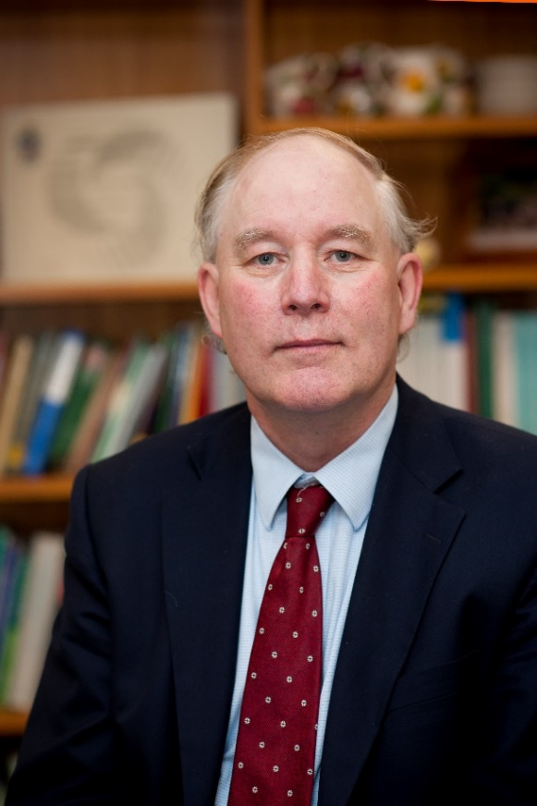 | Professor Paul Moughan was appointed to the foundation chair in monogastric biology at Massey University in 1993 and from 1997-2003 was Foundation Head, Institute of Food, Nutrition and Human Health, Massey University. From 2003 until 2017 he held the position of Foundation Co-Director of the Riddet Institute, a National Centre of Research Excellence in Food Science and Human Nutrition. Professor Moughan currently holds the position of Distinguished Professor at Massey University and Riddet Institute Fellow Laureate. His research has encompassed the fields of human and animal nutrition, food chemistry, functional foods, digestive physiology and sustainable food production. He has published in excess of 450 scientific works. In 1995 he was awarded Doctor of Science and in 1997 was awarded a Personal Chair at Massey University and was elected a Fellow of the Royal Society of New Zealand. He is a Fellow of the Royal Society of Chemistry, Cambridge, England. In 2011 he was appointed Chair of the FAO Expert Consultation to review recommendations on the characterisation of dietary protein quality in humans and has been a frequent contributor to FAO and WHO expert Committees. He has received numerous prestigious international awards for his work, including the New Zealand Prime Minister’s Science Prize in 2012. In 2014 he was awarded an Honorary Doctor of Science from the University of Guelph, Canada and in 2018 the Wageningen University Medal of Honour. Professor Moughan sits on a number of editorial boards for scientific journals and is an adviser to the international food industry. In 2015 he was appointed to the Global Food and Nutrition Security Project, Leopoldina, Germany, under the auspices of the international partnership of science academies (IAP) and reappointed by election (2016) and invited to author the Asia-Australasia “Opportunities and challenges for research on food and nutrition security and agriculture in Asia” Report. In 2016 he was appointed to the Global Dairy Platform (GDP) Global Nutritional Security Advisory Council, Chicago, USA and in 2018 was invited to contribute to authorship of the International Academies Partnership (IAP) International Report on World Food Security. In 2021 he was invited to author a regional IAP policy briefing for the UN Food Systems Summit.
Dr Manny Noakes  Nutrition Consultant,  Director Meat & Livestock Australia Board, Australia  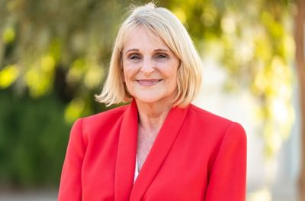 | Dr Manny Noakes is a research scientist in nutrition and health with over 30 years of R&D and nutrition communication experience. She has extensive knowledge in many fields of nutrition and health including the food regulatory system and functional food substantiation, and an in depth knowledge of the role of higher protein dietary patterns in human health and nutrition. She has over 200 scientific publications including research on diet and environmental sustainability. Dr Noakes was instrumental in the development of the CSIRO Total Wellbeing Diet which is underpinned by extensive clinical research, has sold over 1 million copies in Australia and has been further commercialised to a successful online program.  Dr Noakes currently runs her own nutrition consultancy, is a Fellow of the Nutrition Society of Australia, a graduate of the Australian Institute of Company Directors a non-executive director for Meat & Livestock Australia Board.
Dr Didier Dupont  Research Director  French National Institute for Agriculture, Food, and Environment (INRAE), France  Deputy Director of STLO  Chair of Infogest  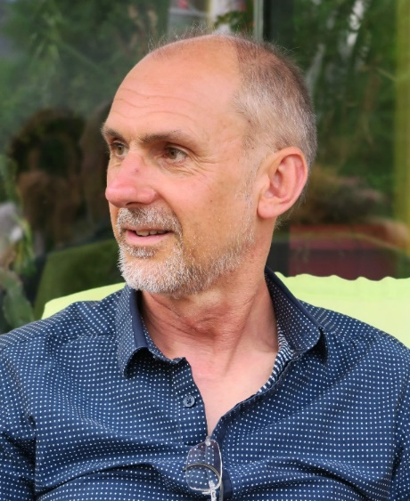 | Dr. Didier DUPONT is a Senior Scientist at INRAE leading the “Bioactivity & Nutrition” group in Rennes that is actively working on the relationships between the structure of food, their digestion in the gastrointestinal tract and the bioavailability of bioactives and nutrients. To reach this goal he has developed in vitro static and dynamic models and has performed in vivo experiments on animal (pig and piglets) and human.  Didier DUPONT is the scientific coordinator of INFOGEST, an international network of more than 150 research institutions gathering 585 experts on food digestion from 46 countries (2011-present). He is the main organizer of the International Conference on Food Digestion.  Didier DUPONT acts as an expert for evaluating scientific proposals in France, Spain, Italy, Canada, Ireland, Israel, The Netherlands, Poland, Chile, New Zealand and Serbia and for assessing new COST Actions. He is a member of the scientific council of several French organizations.  He has written 165 peer-reviewed articles and 17 book chapters, has coordinated a book on “Structure and nutritional effects of food”, given 76 international conferences (53 invited) and is a member of the editorial board of Foods, Frontiers in Nutrition and Future Foods
Dr Simone Osborne  Senior Research Scientist  CSIRO Agricultural & Food  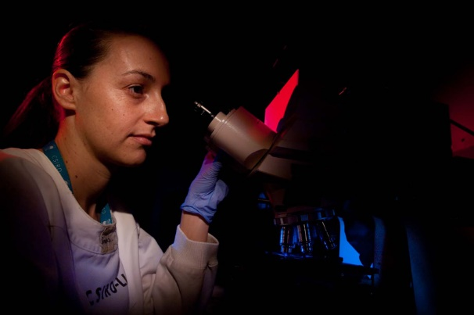 | Dr Simone Osborne is a Senior Research Scientist in the Molecular Nutrition Team in CSIRO Agriculture and Food, based at the Queensland Bioscience Precinct in Brisbane, Australia. Simone uses in vitro digestion models to explore nutrient bioaccessibility and digestibility of new ingredients and whole foods, not only for humans, but also for aquaculture species. Simone also applies digesta to in vitro intestinal cell models to measure intestinal hydrolysis and absorption of target molecules and observe intestinal barrier changes.
Professor Matt Golding  Professor in Food Colloids  Massey University, New Zealand  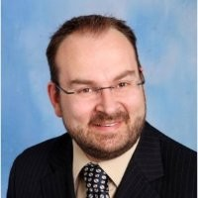 | Matt Golding is Professor of Food Colloids and Principal Investigator within the Riddet Institute.  His teaching interests currently include the application and characterisation ingredients and additives relative to manufactured food structures, material properties and product properties. His research interests are in the fields of food structure design in relation to product performance, with particular focus on colloidal systems, and he is also interested in the behaviour of food systems during digestion and the application of novel ingredient systems in foods.  Prior to joining Massey University, he was a programme leader with Food Science Australia managing research activities in the reduction and regulation of energy content within foods. He has also worked for Unilever R&D in the UK and the Netherlands, managing its emulsions science base which was primarily concerned with the structuring of colloids such as emulsions and foams in a range of soft solid food systems. He currently serves on three editorial boards, and is a member of both the New Zealand Institute of Food Science and Technology, and the Royal Society of Chemistry.
Professor Mike Gidley  Director of the Centre for Nutrition and Food Sciences  University of Queensland, Australia  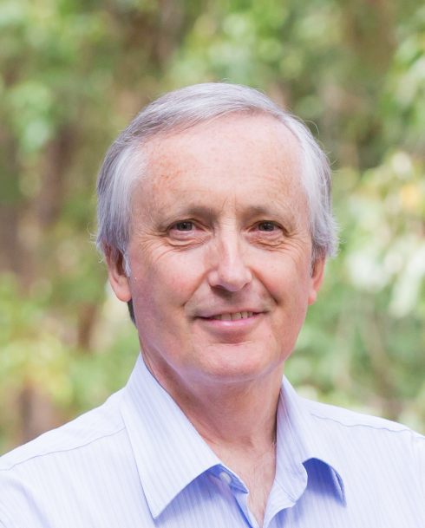 | Professor Mike Gidley is Director of the Centre for Nutrition and Food Sciences (CNAFS) in the Queensland Alliance for Agriculture and Food Innovation at The University of Queensland, Australia. Research themes within CNAFS include:  ‘Smart Selections’ (how to identify the right combinations of raw materials and processing to deliver consumer-preferred foods),  ‘Naturally Nutritious’ (maximising the intrinsic nutritional properties of agricultural products in foods and ingredients) and  ‘Uniquely Australian’ (identifying and validating opportunities for elite products from foods and ingredients that can only have come from Australia).  Prof Gidley’s own research is focused on structure - function - nutrition relationships in plant-based foods and ingredients. This has led to the detailed characterisation of starch and dietary fibre digestion and fermentation both in vitro and in vivo, with the understanding generated leading to opportunities for optimising nutritional value of foods and feeds.
Dr Matt Sinnott  Senior Research Scientist  CSIRO Data 61University of Queensland, Australia  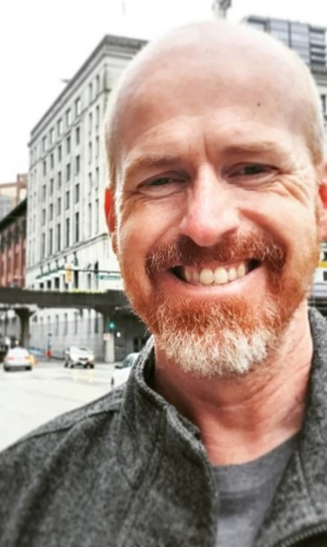 | Matt Sinnott is a CSIRO Data61 Senior Research Scientist with nearly 20 years of commercial experience in advancing the science of world-leading particle-based computational models of industrial-scale devices and biophysical systems. His main research interests are in gastrointestinal transport, multiphase flows, and industrial process engineering with publication of 60 peer-reviewed journal articles and 3 book chapters.
Professor Leo Cheng  Professor at the Auckland Bioengineering Institute  The University of Auckland, New Zealand  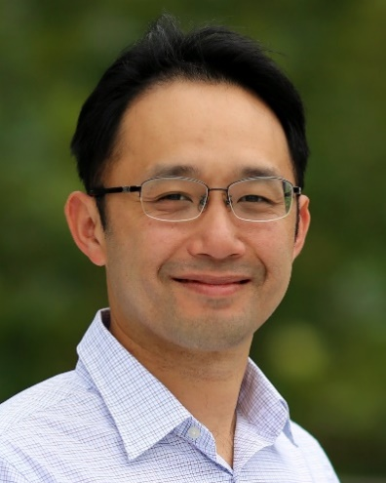 | Leo is a Professor at the Auckland Bioengineering Institute and leads research in gastrointestinal motility and electrophysiology. He graduated from the University of Auckland with a Bachelor of Engineering in Engineering Science with First Class Honours in 1997 and a PhD in Bioengineering in 2002.  Leo's main interests are in improving our understanding of the electrophysiological events in the gastrointestinal tract and their relationship to mechanical function, and the consequences on the food we ingest. He is also interested in developing methods for non-invasively recording and interpreting the weak electrical and magnetic fields that result from skeletal muscles, the heart, and the gastrointestinal tract. Leo has active collaborations with a number of international research groups based in the US (Vanderbilt University, Mayo Clinic, New York Institute of Technology, University of Louisville, University of Alabama at Birmingham, University of Michigan) and Europe (Université libre de Bruxelles, University of Stuttgart, Fraunhofer IPA and Fraunhfoer IZM).
Dr Leif Lundin  Research Director, Food Program, CSIRO Agriculture & Food, Australia  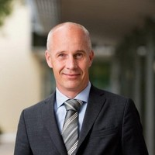 | Dr Leif Lundin is the Research Director for the Food Program in the Agriculture and Food business unit at CSRIO. The role involves managing the cross-cutting research and the relationships with government, industry clients and NGOs. Leif has 25 years of experience working with the food manufacturing industry and their research, development and innovation challenges. Leif has 10 years of experience working for a food manufacturer, Unilever R&D in the UK and the Netherlands as a senior research scientist.  Leif has a Ph D in biopolymer physical chemistry from Chalmers University of Technology in Sweden. Leif is very interested in understanding what happens to food during manufacturing processes and the resulting food quality. Leif’s research has focused on how the food material influences sensory properties such as the texture, taste and flavour.
Dr. Gail M. Bornhorst  Associate Professor  University of California, Davis, USA  Biological and Agricultural Engineering  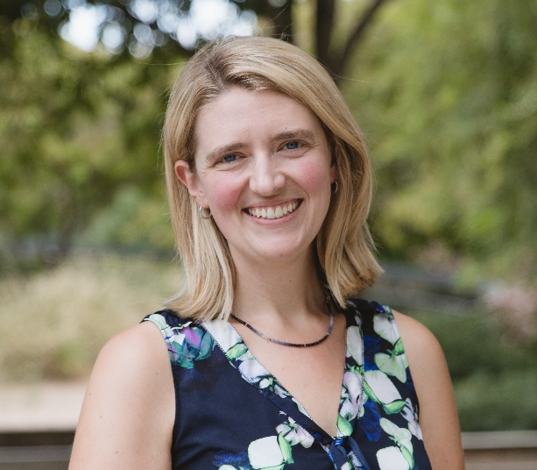 | Dr. Gail M. Bornhorst is an Associate Professor of Food Engineering in the Departments of Biological and Agricultural Engineering and Food Science and Technology at the University of California Davis. She is also an Associate Investigator at the Riddet Institute. She received her B.S. degree from Michigan State University and her M.S. and Ph.D. from University of California Davis in biological systems engineering. Her research involves developing a quantitative understanding of food structural breakdown during digestion and the impact on nutrient release and food functional properties. Her lab also works on development of dynamic in vitro model systems for studying digestion, and modeling of digestion processes. Dr. Bornhorst is currently the Chair of the Food Engineering Division of IFT, and Secretary of the Society of Food Engineering.  Dra. Gail M. Bornhorst es un Asóciate Profesor de Ingeniería de Alimentos en los departamentos
Dr Cathrina Edwards  Career Track Group Leader  Quadram Institute Bioscience, UK | Dr. Cathrina (‘Cat’) Edwards  Career-Track Group Leader, Quadram Institute Biosciences (QIB)  Dr Cathrina Edwards leads a research group within the Food, Innovation and Health programme at Quadram Institute Bioscience in Norwich, UK. Her research group uses various in vitro digestion models to study the rate, extent and site of release of nutrients from foods during gastro-intestinal transit, and undertake human studies to assess the metabolic consequences. Current research activities are focussed on understanding the mechanisms limiting bioaccessibility of starch and protein from pulses. The group are also working with the food industry the develop alternative processing methods to optimise the nutritional value of pulses and other crops.  Cathrina has a PhD in Nutritional Sciences from King’s College London 2010-2014 and has held various postdoc positions (at King’s College London) and a Career Progression Fellowship (at the Institute of Food Research), Norwich, before securing her current Career Track Group Leader position in Dec 2017.  Cathrina has pioneered the development of a novel food ingredient, PulseON® - now available for commercial use via Pulseon Foods Ltd., and continues to be passionate about translational and impactful research
Professor Colin Hill  Principal Investigator  University College Cork, Ireland  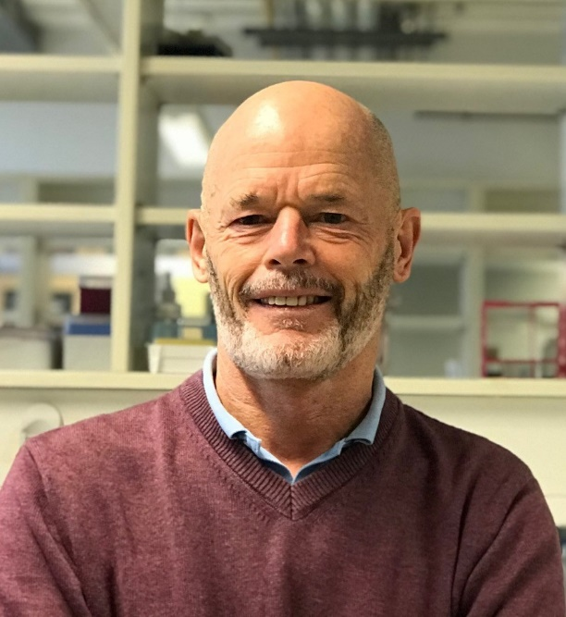 | Colin Hill has a Ph.D in molecular microbiology and is a Professor in the School of Microbiology at University College Cork, Ireland. He is also a founding Principal Investigator in APC Microbiome Ireland, a large research centre devoted to the study of the role of the gut microbiota in health and disease. His main interests lie in the role of the microbiome in human and animal health. He is particularly interested in the effects of probiotics, bacteriocins, and bacteriophage. He has published more than 600 papers and holds 25 patents. More than 80 PhD students have been trained in his laboratory.
Professor Sven Petterson  Nanyang Technological University, Singapore  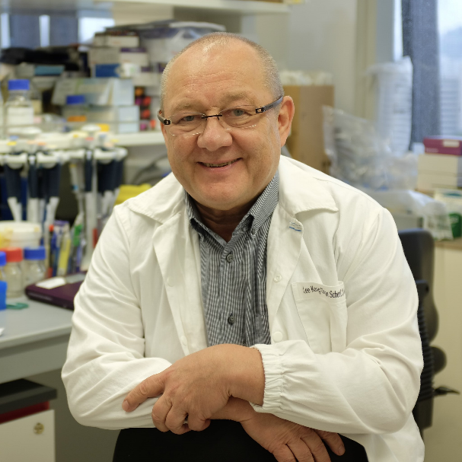 | After completing a PhD in Immunology (1985) at the Umea University and an MD degree (1986), he was awarded the  prestigious EMBO fellow ship to work as a post doc at the famous Laboratory of Molecular Biology (LMB) in Cambridge UK, to work on transcriptional regulation of immunoglobulin genes as post doc fellow (1987 1990). Upon return to Sweden, was awarded 6 year junior research grant from the Swedish Medical Research Council and took a position as Asst Prof at the Karolinska Institute (KI). In 2000, he was offered a strategic chair as Professor in Microbe Host interactions at KI. During his time at KI he was awarded several prices and prestigious grants. In 2010 he took up a position at National Cancer Centre, Singhealth, in Singapore as Senior Principal Investigator. In 2014 he was appointed as Professor in Metabolic Diseases at the LKC School of Medicine (2014 2020). In 2015 he was elected to become Senior Investigator at the Canadian Institute For  Advanced Research (CIFAR) (2015 --). His is an internationally renowned investigator with a string of high-profile publications in gut brain communication and how gut microbes and their metabolites regulate brain development and function in health and disease. He has supervised some 25 students to PhD, (latest two NTU, 2021). organized multiple international conferences and workshops worldwide, He is frequently invited as speaker to Scientific conferences and other international conferences and workshops worldwide, He is frequently invited as speaker to Scientific conferences and other stakeholders relevant to Medical Biology.  In 2020, the Jeffrey Cheah foundation from Malaysia awarded him a grant to establish an ASEAN Microbiome Nutrition Malaysia awarded him a grant to establish an ASEAN Microbiome Nutrition Centre (AMNC) jointly between NNI and Sunway University Malaysia. Recently, the National Neuro Science Institute (NNI), Centre (AMNC) jointly between NNI and Sunway University Malaysia. Recently, the National Neuro Science Institute (NNI), appointed him as Principal Investigator at NNI to work on gut brain communication relevant to human health and onset of neurodegenerative diseases including the role of gut microbes, ageing and development of Parkinson disease. neurodegenerative diseases including the role of gut microbes, ageing and development of Parkinson disease.
Nick Hazell  CEO  V2Food | Nick Hazell is an experienced food innovator, lecturer and consultant who is CEO & Founder of Australian startup v2food. Launched nationally in October 2019, v2food has developed plant-based meat, building on a close collaboration with CSIRO to create tasty, sustainable and healthy products.  Hazell holds a Master of Manufacturing from Cambridge University. He worked in aerospace and chocolate manufacturing before moving into research and development in the food industry, working at global multinationals in The Netherlands and Australia. He was R&D Director at Masterfoods and at PepsiCo Australia and New Zealand, working on products like Grain Waves, Red Rock Deli, Sunbites and Smiths. He lectures in the Bachelor of Creative Intelligence and Innovation at UTS and has consulted to CSIRO and the meat industry.
Gabrielle Munzer  Main Sequence Venture, Australia | Gabrielle joined Main Sequence in 2019 bringing over 15 years of financial markets experience. She has a strong focus on ESG principles and is deeply involved in a number of company creation opportunities.  Gabrielle previously worked in investment banking at ABN AMRO and Morgan Stanley and investment management at Challenger.
Penny Brereton  Commercial Director  NutriV, Australia  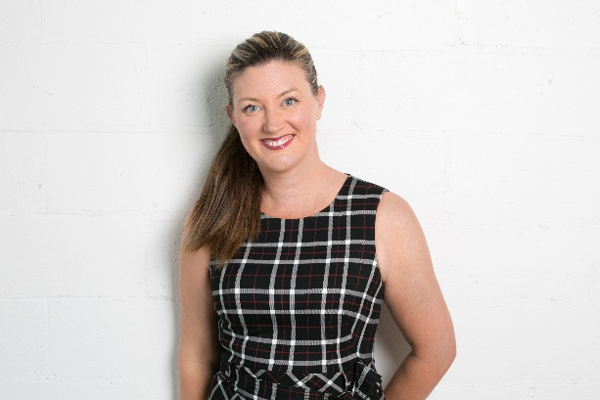 | Penny Brereton is the Commercial Director for Nutri V and a Consultant for TSM Advisory.  Penny is an experienced professional in the areas commercial advisory work, including supporting start up business, project management, risk management, compliance, financial modelling and tendering.  Penny's experience provides valuable skills across the full project management life cycle for outsourced contracts and extensive experience in dealing with the compliance required in the context of government contracts and other highly regulated environments.
Arohaina Owen  Vision Maatauranga  High-Value Nutrition National Science Challenge  The Liggins Institute, University of Auckland | Arohaina’s career to date has been in Financial Services in global corporate company. She holds a Masters in Financial Planning as well as a Bachelor of Arts in Social Policy and Māori business.  Arohaina’s recent role as Working Group Lead for Kaitahi As One provided the iwi (tribe) owned business to engage in Mātauranga Māori and science through their range of frozen smoothy drops which include Māori species including kawakawa and puha.  She is the Vision Mātauranga Leader for High Value Nutrition / Ko Ngā Kai Whai Painga National Science Challenge as well as Pookai Aronui (Director) for Te Pataka o Rauru and Kii Tahi Ltd, investment arms of Southern Taranaki iwi, Ngaa Rauru Kiitahi.
Melanie Ruffell  Stakeholder Relationship Manager  Riddet Institute – Advancing Frontiers in Food Science  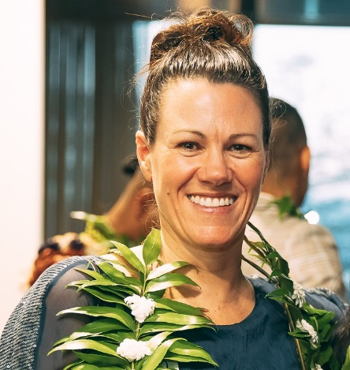 | As the Riddet Institute’s Stakeholder Relationship Manager, Melanie builds strategic partnerships to help ensure the Institute’s work creates real value and transformational change for New Zealand’s agri-food sector. This includes engaging with scientists and research partners; industry stakeholders; Māori and Pacific partners; government agencies; and funding entities such as the High Value Nutrition National Science Challenge. Melanie works to facilitate partnerships that support the aspirations of Māori and Pacific Peoples, through indigenous innovation, research scholarship and leadership.  With a BSc in Human Nutrition (Otago, NZ), Melanie spent 15 years in the UK working with international food companies, scientists, regulators, industry and policy-makers in the high-value nutrition sector. Melanie returned to Aotearoa NZ in 2015, and, prior to joining the Institute, worked with a local food exporter and a global provider of agri-tech services. Melanie particularly enjoys developing meaningful collaborations, working with diverse teams, to help deliver tangible impact and community benefit.
Dr Cuong Tran  Team Leader/Principal Research Scientist  CSIRO Health & Biosecurity  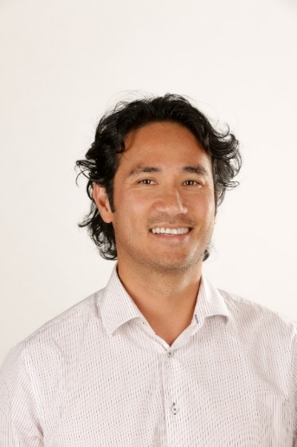 | Cuong is a Senior Research Scientist and at Team Leader at CSIRO Health and Biosecurity, and an Affiliate Senior Lecturer at the University of Adelaide. He has a PhD in nutritional physiology and gastroenterology, and more than 15 years of research experience in gut health and nutrition as well as gut disorders and well-being in paediatrics and adults. Cuong has a research interest in gut barrier function and microbiome in particular in developing effective measures of gut health and function and how that impacts on health and well-being. He has published over 50 peer-reviewed research papers ranging from topics such gut microbiome and health, zinc nutrition as a potential therapy for inflamed conditions of the gut, non-invasive testing for gut health, and small bowel integrity and function. Cuong is currently working on commercialising a gut health test and nutritional solutions to improve population gut health and wellbeing.
Dr Michael Conlon  Principal Research Scientist  CSIRO Health & Biosecurity  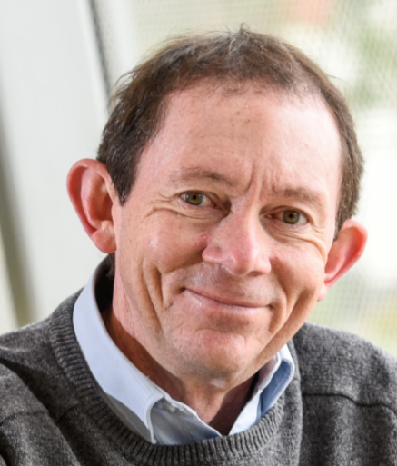 | Dr Michael Conlon is a Principal Research Scientist at CSIRO Health & Biosecurity in Adelaide with over 35 years of research experience in areas related to diet and health. A particular focus has been on the interactions that occur between dietary components such as fibres and proteins, and other components of foods such as polyphenols, and the impacts these have on gut microbes, gut physiology and health. This research has been applied to a wide range conditions, including inflammatory bowel disease, colorectal cancer, allergies and autism, and has involved studying treatment modalities such as probiotics, prebiotics and faecal transplantation.
Professor Harjinder Singh  Director of the Riddet Institute (Centre of Research Excellence)  Massey University, New Zealand.  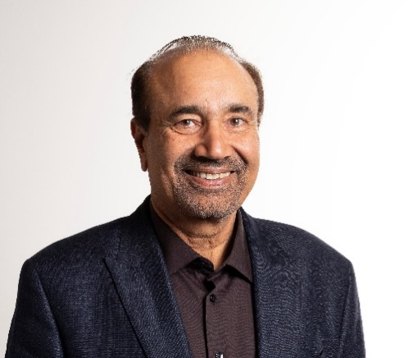 | Professor Harjinder Singh is the Director of the Riddet Institute (Centre of Research Excellence), Massey University, New Zealand. His research expertise includes dairy science and technology, functional foods, food colloids, structures, and nutrition. He has published over 350 research papers in international journals. He is a Fellow of the Royal Society of New Zealand and a Fellow of the International Academy of Food Science and Technology, and has received several international awards, including the Marschall Rhodia International Dairy Science Award, the William C. Haines Dairy Science Award (USA) and the New Zealand Prime Minister’s Science Prize.
Dr Alejandra Acevedo-Fani  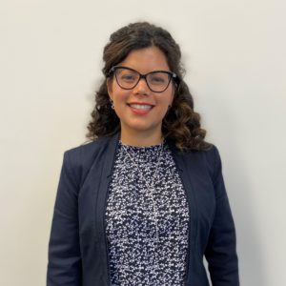  Research Officer | Riddet Institute | Massey University | Dr Alejandra Acevedo-Fani is a Research Officer at the Riddet Institute, Massey University, New Zealand. Her research areas include the delivery of bioactive compounds, food digestion, and the development of healthier future foods. She graduated cum laude from the University of Lleida (Spain), with a Ph.D. in Food Science and Technology. She was awarded a ‘Student of the Year’ prize in 2016 by the European Federation of Food Sci & Tech, with her research on ‘nanostructured emulsions and nanolaminates as an approach to deliver active ingredients”. In 2017, Alejandra joined the Riddet Institute to develop her research interests in food digestion, food structure design, and health. In 2019, she was awarded a Marie-Curie Fellowship hosted by the International Iberian Nanotechnology Laboratory in Portugal, which she undertakes jointly with her role at the Riddet Institute.
Dr Ingrid Appelqvist  Food Innovation Centre | Leader  Senior Principal Research Scientist  CSIRO Agriculture and Food  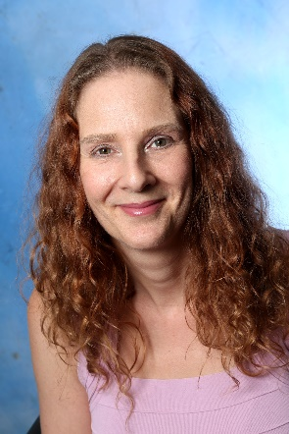 | Ingrid is a senior principal research scientist and the Group Leader for Food Innovation centre in CSIRO Agriculture and Food. The group research involves engaging clients to develop bespoke solutions and accelerate innovation to enable delivery in new product and process development, accessing new  Ingrid’s research interest in healthy ageing has been in designing food with controlled break down kinetics and it’s restructuring in the GI tract to support increased health and wellbeing beyond just providing nutrition. Control of breakdown to release nutrients at a slow rate can reduce the spikes and troughs that the body must cope with, reducing stress on the digestive system and body.
Dr Amy Logan  Food Quality and Safety Group Leader | Healthy Foods Impact Area Lead  CSIRO Agriculture & Food | Dr Amy Logan is the Group Leader for Food Quality and Stability within CSIROs Food Program in Australia.  A lipid chemist by training, she has many years’ experience understanding the structure-function relationship of food systems that includes the influence of composition and processing on the structure of soft materials and how this effects product behaviour, e.g. stability, texture and sensory.  Her research interests include Personalised Nutrition, and involves the development of structured foods for the delivery of personalised nutrition specific to a person’s individual needs (physiological needs, lifestyle requirements, genetics); the additive manufacturing of foods (including 3D printing) to prepare structured foods on-demand; the development of texture modified foods for differing market segments including the elderly (with a focus on dysphagia and sarcopenia); and the effect of food structure on digestion kinetics.

