CSIRO LAND AND WATER
Waste innovation for a circular economy

  - Cutting Edge Science and Engineering Symposium

May 27-29, 2019, Clayton, Victoria

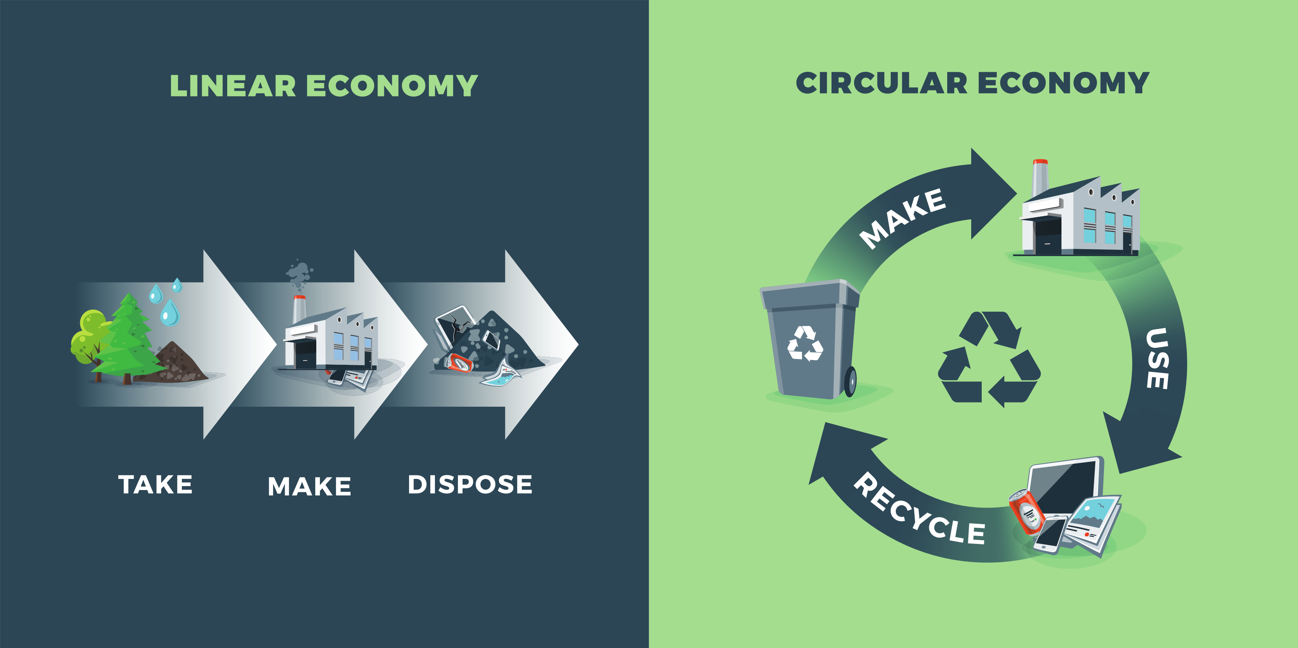

Table of Contents

Welcome
Waste drives a multi-billion-dollar industry. Next-generation technologies for re-using, re-purposing and recovering value from waste streams are critical to the transition towards a Circular Economy. The development of innovative technologies for resource recovery and long-term management of priority wastes can generate new industries and revenue for Australia, as well as contribute to policy, regulation and business models to support the Circular Economy in Australia.
Throughout the 2.5-day symposium, we will showcase international and national cutting edge research in waste innovation and Circular Economy, as well as provide a forum to discuss the development of innovative and sustainable waste practices in Australia. Speakers and delegates are from a diverse range of backgrounds, ranging from academic, research organisation, government and industry, which reflects the coordination required to establish and maintain a circular economy in Australia.
The symposium provides an excellent opportunity to engage and discuss the technical challenges associated with sustainable waste management, resource and energy recovery and a circular economy, but also the intersection of regulatory, economic and social barriers that impact circularity in Australia as we move forward in this challenging environment. This workshop is underpinned by a larger Circular Economy in Australia initiative that is being coordinated by CSIRO, and the learnings from this workshop will help shape our thinking and allow us to establish new connections and collaborations across the stakeholder groups to advance this area of research further than thought possible.

Welcome to our symposium!

Dr Naomi Boxall,
Research Scientist, CSIRO Land and Water
On behalf of the Organising Committee

Organising Committee

Naomi Boxall, CSIRO Land and Water
Dr Naomi Boxall researches waste innovation and biotechnological processes for environmental and industrial applications in the mining, water supply and wastewater treatment industries. Research topics have included bioleaching of metals from minerals and metal containing waste materials, biological oxidation of iron, removal and recovery of metals from mine and process waters, wastewater treatment and resource recovery, biofouling and biocorrosion, bioremediation of contaminated sites, molecular detection and monitoring of microbial communities in natural and engineered environments, and isolation and description of novel microorganisms. Currently researching the development of a circular economy in Australia, and innovative waste management for multiple industries to benefit our economy.
Contact details: Naomi.Boxall@csiro.au; 08 9333 6260; 0437617158

Anna Kaksonen, CSIRO Land and Water
Dr Anna Kaksonen leads the Biotechnology and Synthetic Biology Group in the Environmental Contaminant and Mitigation Biotechnology Program in CSIRO Land and Water. She is researching the use of microorganisms and biotechnological processes for environmental and industrial applications in the mining, water supply and wastewater treatment industries. Research topics of special interest have included: bioleaching of metals from minerals and metal containing waste materials, biological oxidation and removal of iron from bioleach circuits, removal and recovery of metals from mine and process waters, wastewater treatment and resource recovery, drinking water and stormwater microbiology, biofouling, biocorrosion, biofilm sensors, deep biosphere microorganisms, production of bio-H2 and bioethanol using dark fermentation, bioremediation of contaminated sites, molecular detection and monitoring of microbial communities in natural and engineered environments, and isolation and description of novel microorganisms.

Sarah King, CSIRO Manufacturing
Sarah King is a senior research consultant working in Manufacturing for CSIRO, Australia’s National Science Agency. Sarah’s research interests are sustainable manufacturing, innovation networks and industrial symbiosis. Sarah is delivered ASPIRE (Advisory System for Processing, Innovation and Resource Exchange) which is a web-based system that helps firms find solutions for waste or by-products, create new business to business collaboration and gain access to innovation partners. Sarah also led the highly successful pilot of Lean Launch Pad (LLP) into CSIRO. LLP is an entrepreneurial, start-up program for CSIRO researchers. Sarah was involved in designing, planning and facilitating this program in Melbourne and Sydney, including recruiting our first external, industry mentors. Sarah's efforts were critical in establishing the program which has been highly successful and since been implemented Australia wide through the CSIRO ON Program. Sarah has over fifteen years’ experience working in the Manufacturing, R&D, Forestry, Agriculture and IT sectors. Sarah holds a Bachelor of Forestry Science from Canterbury University and a Master of Corporate Environmental Sustainability Management from Monash University. Sarah is currently a PhD candidate at Swinburne University of Technology researching innovation networks.

Daniel Roberts, CSIRO Energy
Daniel leads CSIRO's Hydrogen Energy Systems Future Science Platform. The Hydrogen FSP plays an important role in CSIRO's broad hydrogen RD&D program, by providing a strong scientific and technical foundation to CSIRO's work in enabling a renewable energy export industry based on hydrogen.
Before taking on the FSP role, Daniel led the High Efficiency Thermal and Electrochemical Technologies research group within CSIRO Energy. He continues to play a senior role in CSIRO’s gasification research activities, in particular thermochemical pathways for bioenergy production from biomass and waste, and on behalf of Bioenergy Australia, he is the National Task Leader for IEA Bioenergy Task 36 “Material and Energy valorisation of waste in a Circular Economy”.

Christina Morris, CSIRO Land and Water
Christina Morris is a Senior Experimental Scientist in Land and Water working on the research and development of microorganisms in the mining and wastewater industries. Christina is the technical lead on multiple projects, including the discovery of new microorganisms that can serve as catalysts for industrial biotechnological applications.

Warren Bruckard, CSIRO Mineral Resources

Site information

Location and getting there
CSIRO Clayton is approximately 45 km from Melbourne airport, and travel time from the airport to Clayton can range from 40 to 60 minutes, depending on traffic. The site is located approximately 20 km south-east of the Melbourne CBD, and travel time from CBD can range from 20 to 50 minutes, depending on traffic. Please allow additional travel time for peak periods of traffic.
CSIRO Clayton is best reached by car or taxi. Some public transport is available, including a train to and from Melbourne (Pakenham line) with a connecting bus to Monash University (742, 601, 900), which is located across the road from CSIRO Clayton. Travel time by public transport from Melbourne CBD is from 40 to 60 minutes, depending on the route. Should you require assistance planning your travel to and from the workshop, please contact us directly.
The workshop will be held in the Ian Wark Lecture theatre, which is in Building 203, at CSIRO’s Clayton, Victoria site. A map showing the location of the building and the proximity to parking is shown in Figure 1. Limited parking is available on site.
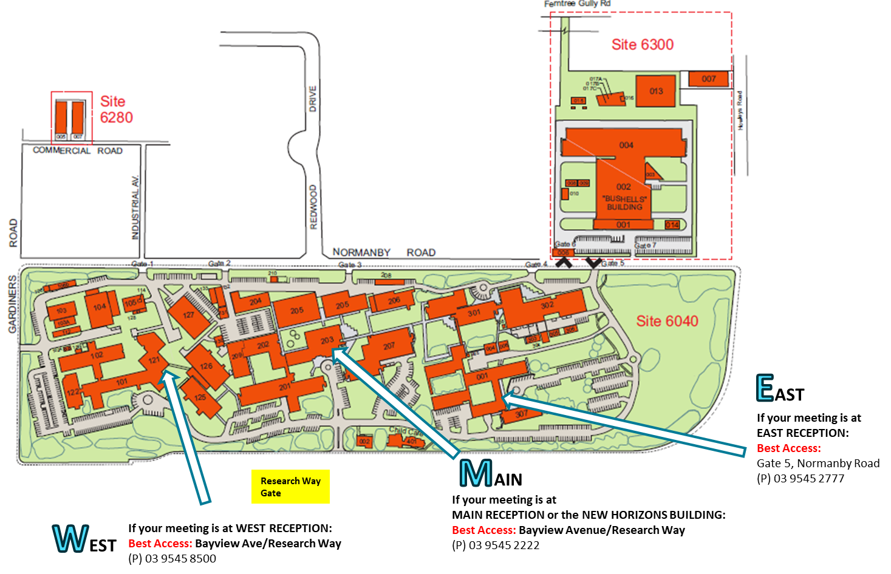
Figure 1 Location map of the CSIRO Clayton site. The Ian Wark Lecture Theatre is located in Building 203, which can be found at the MAIN RECEPTION, and accessed through the Research Way gate. Limited paring will be available around this building for visitors.

Accommodation
There are several accommodation options including hotels, motels and serviced apartments located within 5 km of the CSIRO Clayton site at Monash University, Clayton, Notting Hill and Glen Waverley. A suggested list is included below.
Quest Glen Waverley
https://www.questapartments.com.au/properties/vic/glen-waverley/quest-glen-waverley/overview

Campus Clayton Serviced Apartments (4.4-star hotel)
http://www.campusclayton.com/

Quest Notting Hill (4.8-star hotel)
https://www.questapartments.com.au/properties/vic/notting-hill/quest-notting-hill/overview

Gateway on Monash Hotel (3.8-star hotel)
http://gatewayonmonash.com.au/accommodation/

Glen Inn (3-star hotel)
http://gleninn.com/

Hotel Bruce County (4-star hotel)
http://brucecounty.com.au/

Apartments of Waverley (4-star hotel)
https://apartmentsofwaverley.com.au/

Clayton-Monas Motor Inn and serviced apartments (3.5-star hotel)
http://www.claytonmonashmotorinn.com.au/

Monash Hotel (3-star hotel)
https://www.monashhotel.com.au/

Alternatively, some visitors choose to stay closer to the city and commute to and from the site as required. Restaurants and amenities closest to the Clayton site are located in Glen Waverley.
Should you require assistance with booking accommodation for the workshop, please contact us directly.

Agenda

DAY 1 – May 27, 2019
8:30-8:45 | Registration
8:45-9:00 | Welcome to country, housekeeping, HSE and introduction to symposium  Dr Naomi Boxall, CSIRO Land and Water
9:00-9:15 | Symposium Opening  Stan Krpan, Chief Executive Officer, Sustainability Victoria
Session 1: Circular economy and state of waste in Australia
Chair: Dr Naomi Boxall, CSIRO Land and Water
9:15-9:45 | Process Metallurgy is Fundamental to the Circular Economy  Prof Dr Dr Markus Reuter, Helmholtz Institute Freiberg
9:45-10:15 | The circular economy in Australia  Dr Heinz Schandl, CSIRO Land and Water
10:15-10:45 | MORNING TEA
Session 2: The second life of plastics
Chair: Dr Daniel Roberts, CSIRO Energy
10:45-11:05 | A Narrative on the Global Recycled Plastics Market: Analysis & Trends  Dr Katherine Locock, CSIRO Manufacturing
11:05-11:25 | Closing the carbon cycle through molecular recycling of problematic plastic waste via gasification  Dr Joerg Kleeberg, IEC, Technische Universität Bergakademie Freiberg, Germany
11:25-11:45 | Microfactory TechnologiesTM: The Science of “Microrecycling”: Selective Synthesis of Materials from Waste  Prof Veena Sahajwalla, UNSW
11:45-12:05 | Enzyme design for next generation plastic biodegradation  Dr Albert Ardevol Grau, CSIRO Manufacturing
12:05-12:20 | ECR Science Snapshot 1  The success of getting consumers to reduce, reuse and refill bottled water?  Kathy Willis, CSIRO Oceans and Atmosphere
12:20 – 1:30 | LUNCH
Session 3: Making the most of our metal wastes
Chair: Dr Anna Kaksonen, CSIRO Land and Water
1:30-1:50 | Metal flows and recovery of metals from urban and mine wastes  Dr Artem Golev, Sustainable Minerals Institute, University of Queensland
1:50-2:10 | Mine waste as an economic prospect  Dr Anita Parbhakar-Fox, Sustainable Minerals Institute, University of Queensland
2:10-2:30 | Integrated Approach in Recycling of Electronic Wastes  Assoc Prof Majorie Valix, University of Sydney
2:30-2:50 | The challenges of recycling batteries in Australia  Andrew MacKenzie, Envirostream
2:50-3:05 | ECR Science Snapshot 2  An integrated biohydrometallurgical approach for metal recovery from e-wastes  Jonovan Van Yken, CSIRO Land and Water
3:05-3:30 | AFTERNOON TEA
Session 4: Diverting urban waste from landfill
Chair: Warren Bruckard
3:30-3:50 | Waste-to-Energy Concepts in a Circular Economy  Dr Daniel Roberts, CSIRO Energy
3:50-4:10 | Turning food loss into innovative food and beverage  Kirthi deSilva, CSIRO Agriculture and Food
4:10-4:30 | Anaerobic Digestion of Food Waste for a Circular Economy  Prof Bernadette McCabe, Centre for Agricultural Engineering, University of Southern Queensland
4:30-4:50 | Recycling More - Chemically recycling End-of-Life Plastic with the Cat-HTR platform Andrea Polson, Licella and iQRenew
4:50-5:10 | Day 1 summary and close  Dr Naomi Boxall, CSIRO Land and Water
6:00 | Speaker and Organising Committee Dinner

DAY 2 – May 28, 2019
9:00-9:05 | Welcome and introduction to day 2  Dr Naomi Boxall, CSIRO Land and Water
9:05-9:35 | Wasting Innovation or Innovation in Wastes?: The challenges of delivering a circular economy.  Dr Anna Littleboy, SMI, University of Queensland
Session 5: Nuclear Waste Management
Chair: Dr Naomi Boxall CSIRO Land and Water
9:35-9:55 | Strive to be the Forerunner in Safe Radioactive Waste Handling and Storage  Dr Erika Holt, VTT Finland
9:55-10:15 | Nuclear waste: from once-through to a closed fuel cycle  Dr Dirk Mallants, CSIRO Land and Water
10:15-10:30 | ECR Science Snapshot 3  Environmental tracers as a tool to assess possible release pathways associated with underground disposal of radioactive waste  Dr Christoph Gerber, CSIRO Land and Water
10:30-11:00 | MORNING TEA
Session 6: Social, economics and logistics
Chair: Dr Anna Littleboy
11:00-11:20 | Social and policy levers for transitioning to a circular economy  Dr Nick Florin, University of Technology Sydney
11:20-11:40 | ASPIRE – Digital matchmaking for the waste industry  Sarah King, CSIRO Manufacturing
11:40-12:00 | What can blockchain do for the circular economy?  Hugo O’Connor, Data 61, CSIRO
12:00-12:20 | Characterisation of Bangladeshi waste mobile phone printed circuit boards and techno-economic evaluation of an e-waste recycling plant  Khairul Islam, CSIRO Mineral Resources
12:20-12:30 | GROUP PHOTO
12:35– 1:30 | LUNCH
Session 7: Opportunities, future and gaps
Chair: Sarah King, CSIRO Manufacturing
1:30-1:50 | A circular economy policy and action plan for Victoria  Angela Hoefnagels, DELWP, Victoria.
1:50-2:10 | Vaughan Levitzke  Green Industries, SA
2:10-2:30 | Industry perspective  Veolia – Laurie Kozlovic
2:30-3:00 | Panel discussion  What are the major challenges and opportunities in waste innovation and circular economy?  Angela Hoefnagels, DEWLP  Vaughan Levitzke, Green Industries SA  Laurie Kozlovic, Veolia  CSIRO, Heinz Schandl
3:00-3:30 | AFTERNOON TEA
3:30-4:45 | Mini workshop: Reflections for the past 2 days  Facilitator: Sarah King, CSIRO Manufacturing  Group Moderators: Dr Naomi Boxall, Dr Heinz Schandl, Warren Bruckard, Anna Kaksonen  In small groups, consider the following questions:  - What can Australia do with the 3Rs (Reduce, Reuse Recycle)? i.e. what waste streams do we need to add value to?  - What new technologies, products or processes does Australia need to design for circular economy?  - How can we connect supply chains, cities or regional areas so they are part of the circular economy?  - What does each stakeholder need to do to enable circular economy and who is missing from the conversation?
4:45-5:00 | Day 2 Summary and Close
5:00-6:30 | Workshop networking

DAY 3 – May 29, 2019
8:50-9:00 | Welcome and introduction to day 3  Naomi Boxall, CSIRO Land and Water
9:00-9:15 | Day 3 Opening  Dr Cathy Foley, CSIRO Chief Scientist
9:15-10:35 | Workshop Session - Facilitator: Sarah King  Group Moderators: Dr Cathy Foley, Sarah King, Dr Naomi Boxall, Dr Heinz Schandl  After an introduction to the session, breakout groups for several priority areas consider:  a) short term, future and system changes  b) strengths, weaknesses, opportunities and threats for a circular economy in Australia.
10:35-11:00 | MORNING TEA
11:00-11:15 | Workshop Continued…  Developing a 2040 Circular Economy Future Snapshot
11:15-12:30 | Group presentations and discussion  Facilitators: Sarah King, CSIRO Manufacturing and Dr Cathy Foley, CSIRO Chief Scientist  15 minutes per group (5 groups)
12:30-12:40 | Meeting summary  Dr Cathy Foley, CSIRO Chief Scientist
12:50-13:00 | Meeting close and next steps  Dr Naomi Boxall, CSIRO Land and Water
13:00-2:00 | LUNCH
2:00 on | Optional technical tours through CSIRO Clayton research facilities

Speaker information
Dr Markus Reuter, Helmholtz Institute Freiberg
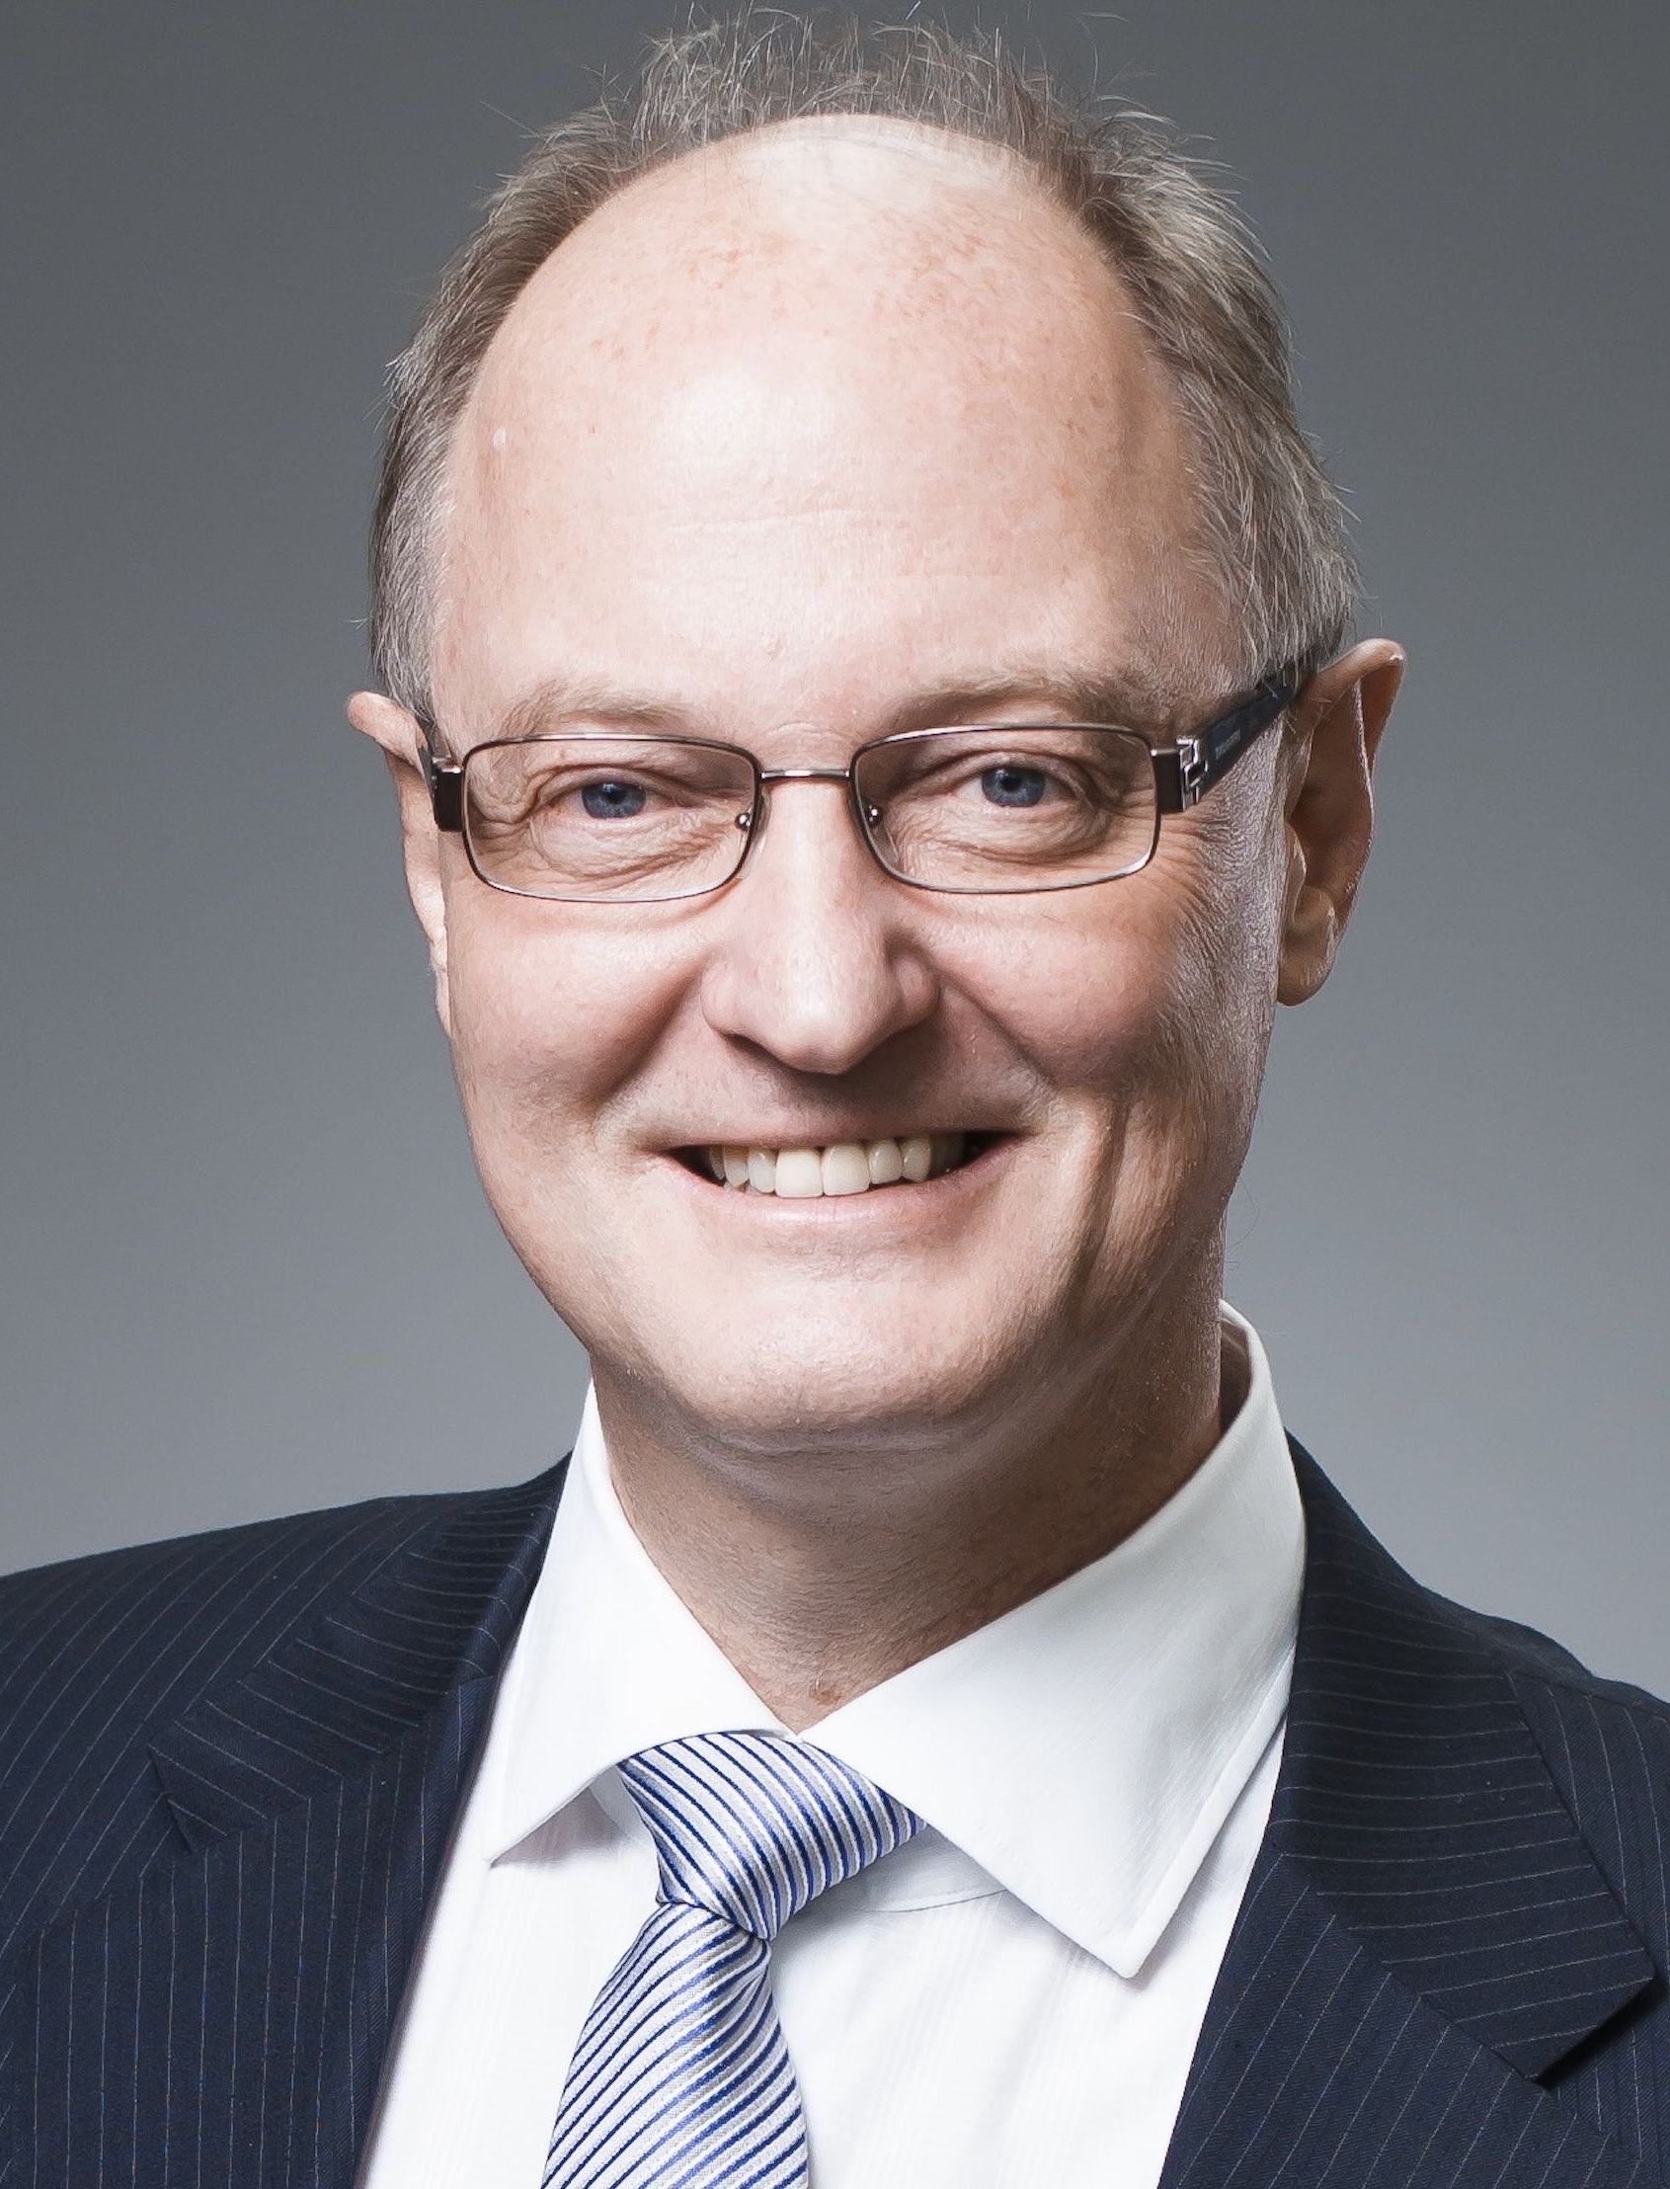
Director at Helmholtz Institute Freiberg for Resource Technology. Industry: Chief Technologist Ausmelt Australia & Director Technology Management Outotec Australia and Finland 2006-2015. Mintek & Anglo American Corporation (South Africa). Academic: Professor at TU Delft (Netherlands) 1996-2005. Honorary & adjunct professorships since 2005 @ TU BAF Freiberg (Germany); Aalto University (Finland); Central South University (China), Melbourne University (also full professor) & Curtin University Perth (Australia). Education: Honorary Doctorates University of Liège (Belgium) & University of Stellenbosch (South Africa); D.Eng. & PhD Stellenbosch University (South Africa); Dr. habil. RWTH Aachen (Germany). Research and industrial interests: Process metallurgy, system engineering, process design, optimization and simulation, recycling and design for recycling; all in the context of sustainability and the circular economy paradigm.
Presentation title: Process Metallurgy is Fundamental to the Circular Economy
Description: Metals are eminently recyclable, and by recycling and refining complex materials, the interconnected metals sector is responding to the increasing scarcity of certain metals. In this way, the metals sector is delivering and recovering the technology and base metals for the Circular Economy (CE). Moreover, metals are at the heart of the energy infrastructures that now run Circular Cities, and they will play an even greater part in the future. Metals are key enablers in the CE, as it is capable of dissolving and carrying a multitude of technology elements. The recovery and recycling of several critical technology elements is based on refining them from molten metal through well-developed metallurgical processes in which these act as carrier metals. To put it simply, process metallurgy is fundamental if countries want to innovate leading positions in the global CE. This presentation is gleaning from a recent policy brief developed by industry and academia within the EU ETN SOCRATES: B. Blanpain, M.A. Reuter, A. Malfliet: Lead Metallurgy is Fundamental to the Circular Economy: https://etn-socrates.eu/pb-metallurgy-circular-economy/

Dr Heinz Schandl, CSIRO Land and Water
Dr Heinz Schandl holds a PhD in Sociology and is a senior science Leader at CSIRO’s Land and Water Division in Canberra. His research combines social theory, industrial metabolism and public policy to develop a knowledgebase for policy makers in the domains of resource efficiency, waste minimization, greenhouse gas abatement and the circular economy. He explores how a transition to sustainable consumption may be facilitated through experimentation and systems innovation. Heinz is also an adjunct professor of Nagoya University, a member of the United Nations Environment Program International Resource Panel and the current president of the International Society of Industrial Ecology.
Presentation title: The circular economy in Australia
A transition to a circular economy in Australia offers new business opportunities, helps revitalise manufacturing in Australia, creates additional employment and has large environmental benefits. This presentation will identify the opportunities that exist in major provisions of construction and housing, transport and mobility, agriculture and food, energy and for long-lived consumer goods. It will also show that in the short term there are many economically attractive options for resource efficiency and waste minimization, and that in the long run a circular economy is superior to business as usual. A transition to a circular economy, however, is not going to happen spontaneously and will benefit form well designed polices and incentives that drive this transition.
Dr Katherine Locock, CSIRO Manufacturing
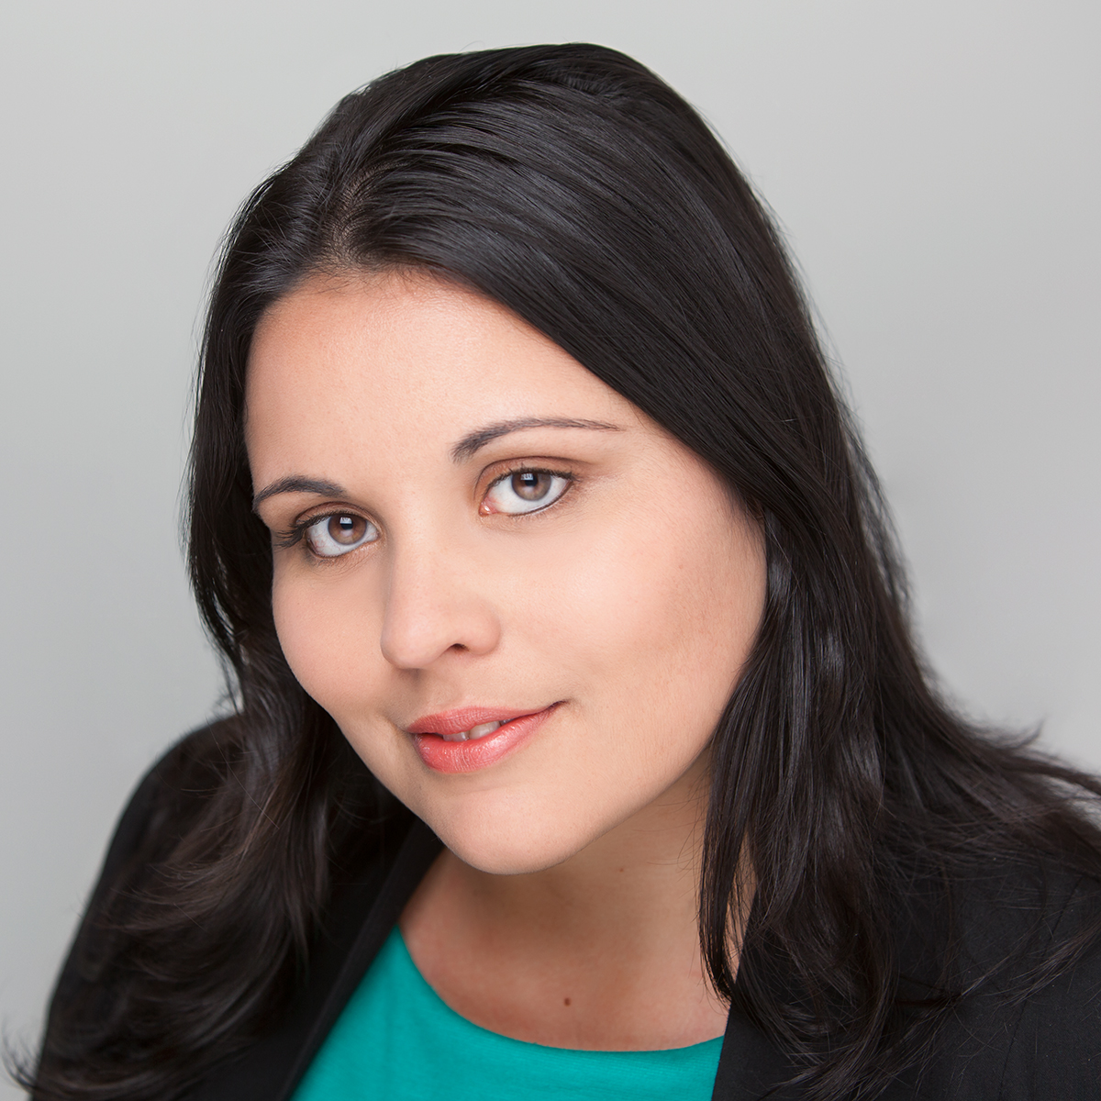
Dr Katherine Locock is a Research Scientist in the Manufacturing Business Unit of the CSIRO in Melbourne, Australia. Her research focuses on radical polymerization, including CSIRO’s patented RAFT technology. Katherine also held a position as a Royal Australian Chemical Institute (RACI) board member for 2016-2018 and sits on the RACI Inclusion and Diversity Committee. She also undertook a short-term placement in 2016 as an advisor to Senator Kim Carr, Shadow Minister for Innovation, Industry, Science and Research the BioMedVic Researcher in Residence Program. In recognition of her track record, Katherine was selected as the AIPS Victorian Young Tall Poppy of the Year in 2016, received a Julius Career Development award in 2016 and the CSIRO Staff Association Women in Science award in 2013.
Presentation title: A Narrative on the Global Recycled Plastics Market: Analysis & Trends
Katherine has headed up a team who have produced a comprehensive Global and Recycled Plastics Market Analysis Report in 2017 which draws on expert opinion sourced from key research, industry and government stakeholder interviews, intellectual property landscape studies and market analysis reports into the plastic recycling industry. She will be presenting an overview of the findings from this report, covering market forecasts, trends, major system/technological gaps, likely growth strategies and the outlook for the industry.

Dr Joerg Kleeberg, IEC, Technische Universität Bergakademie Freiberg, Germany
Study and PhD in Environmental and Plant Engineering (TU Bergakademie Freiberg, Germany). Industrial and scientific background:
- Research Group Leader, material and process analysis (VIRTUHCON project) at the Institute of Institute of Energy Process Engineering and Chemical Engineering (TU Bergakademie Freiberg)
- Lead Engineer, technology development and process engineering, Linde AG, Engineering Division, Dresden
- Lead Engineer, R&D and process engineering, Choren Industries GmbH, Freiberg
- Research Associate, at Institute for Mineral Processing Machines, TU Bergakademie Freiberg
- Project Engineer, Krupp Fördertechnik GmbH, Essen
Presentation title: Closing the carbon cycle through molecular recycling of problematic plastic waste via gasification
The tightening of regulations for plastic waste disposal in Germany, the ban of plastic waste imports by China, and the increasing amount of problematic plastic waste (e.g. carbon fiber, composite materials, mixed plastic waste) entering the recycling system are drivers for innovative solutions for sustainable plastic waste disposal in Germany. To date, the German waste hierarchy is defined as reduce, reuse, material recycling, incineration before disposal. In order to resolve the growing plastic waste challenge, market interest in integrating chemical recycling as the step before incineration – especially for problematic plastic waste which challenges material recycling and cannot be safely disposed of via incineration – is growing exponentially. Chemical recycling is carried out via solvolysis, pyrolysis and gasification. In particular gasification, through breaking down plastic waste into CO, H₂ (syngas) and CO₂ which are the key building blocks for synthesis chemistry, supports a closing of the carbon cycle whereby plastic waste – in dependent of its origins and characteristics – can be used to generate a whole spectrum of new chemical products. In the presentation, the demands on gasification technologies for closing the carbon cycle, first experimental results as well as an international overview of innovations in gasification technologies for plastic waste (EBARA, ENERKEM, IEC) will be presented and discussed.
Prof Veena Sahajwalla, UNSW SMaRT Centre
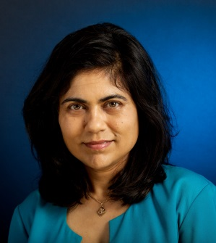
Australian Research Council (ARC) Laureate Professor Veena Sahajwalla is an internationally recognised materials scientist, engineer and inventor revolutionising recycling science. She is renowned for pioneering the high temperature transformation of waste in the production of a new generation of ‘green materials.’ In 2018 Veena launched the world's first e-waste microfactory. As the founding Director of the Centre for Sustainable Materials Research and Technology (SMaRT) at the University of New South Wales, Sydney, she is producing a new generation of green materials and products made entirely, or primarily, from waste. Veena also heads the ARC Industrial Transformation Research Hub for ‘green manufacturing’, a leading national research centre that works in collaboration with industry to ensure new recycling science is translated into real world environmental and economic benefits.
Presentation title: Microfactory TechnologiesTM: The Science of “Microrecycling”: Selective Synthesis of Materials from Waste
In conventional recycling, we convert like for like, using glass or plastics to make more of the same. Today’s waste stream presents a different challenge: its complex and cannot simply separated and feed into a giant processing machine and converted back into their original form. A significant proportion of problematic e-waste is also landfilled and stockpiled. In this situation, how can we make sense of this complexity? “Microrecycling” based technology could be set up almost anywhere in the world via microfactory. This science and technology can potentially protect the environment from the undesirable impacts of landfilling toxic waste streams, reducing burdens on natural resources and enabling manufacturer’s access to secondary resources that would otherwise be sourced from more and more expensive raw materials. “Micorecycling” could transform waste into value-added materials at a local level and contribute to global supply chains. They could form pathways for micro-economies, based on materials production in green microfactories, to develop and generate jobs of the future. They will create local economic opportunities by allowing multiple small-scale operators to generate value-added resources, by reforming waste. This offers new solutions for transformation of waste materials into value, reducing waste pollution, and ultimately eliminating negative social consequences of waste in many disadvantaged communities globally.
Prof Veena Sahajwalla is leading the global race to create microfactory technology that is successful in untangling the complexity of electronic waste, through her selective thermal transformation solutions, which bring a small-scale solution to the world’s massive waste problem for the first time. In future, these microfactories will enable industries to produce many products and resources using materials largely derived from waste. By decentralising manufacturing, this new microfactory technology will also bring positive economic and social impacts, particularly in remote locations such as island markets or regional areas, where the logistics of waste transportation and processing are prohibitively expensive. Through the microfactory technology, we can enhance our economy and be part of the global supply chain by supplying more valuable materials around the world and stimulating manufacturing innovation in Australia.
Dr Albert Ardevol Grau, CSIRO Manufacturing
Dr Ardevol Grau applies methods of theoretical enzymology to design enzymes with novel reactivity for biotechnological applications. Computational modelling of enzymatic catalysis is a multi-level process that requires high-throughput virtual screening of ligand libraries, enhanced sampling of the conformational phase space, free energy calculations and QM/MM molecular dynamics simulations. He uses an iterative optimization process of rational in-silico design and biochemical/biophysical characterization to create a protein scaffold with an active site to accommodate the reaction and the substrate of interest.
Presentation title: Enzyme design for next generation plastic biodegradation
The use of plastic materials has spread to all industries and manufactured products for their outstanding mechanical properties, malleability, thermal and chemical stability and low price. Most plastics are very difficult to degrade, which is good for storage, packaging and durability of the products, but it hampers disposal and recycling of the material. Recently, several enzymes have been found to be able to degrade certain plastics and in PET. However, the low turnover and low thermostability hinders their use for industrial and recycling applications. The 3D structures of some of these enzymes have enabled the rational design of new recombinant proteins with improved properties. To further embrace the rational design of the PETase enzymes, we are using computational methods to model the enzyme-PET interactions and the reaction mechanism. With virtual docking, MD and QM/MM free energy calculations, we can predict the effect of target residues that can be modified to improve the hydrolytic activity and the biophysical properties of the enzymes.

Kathy Willis, CSIRO Oceans and Atmospheres
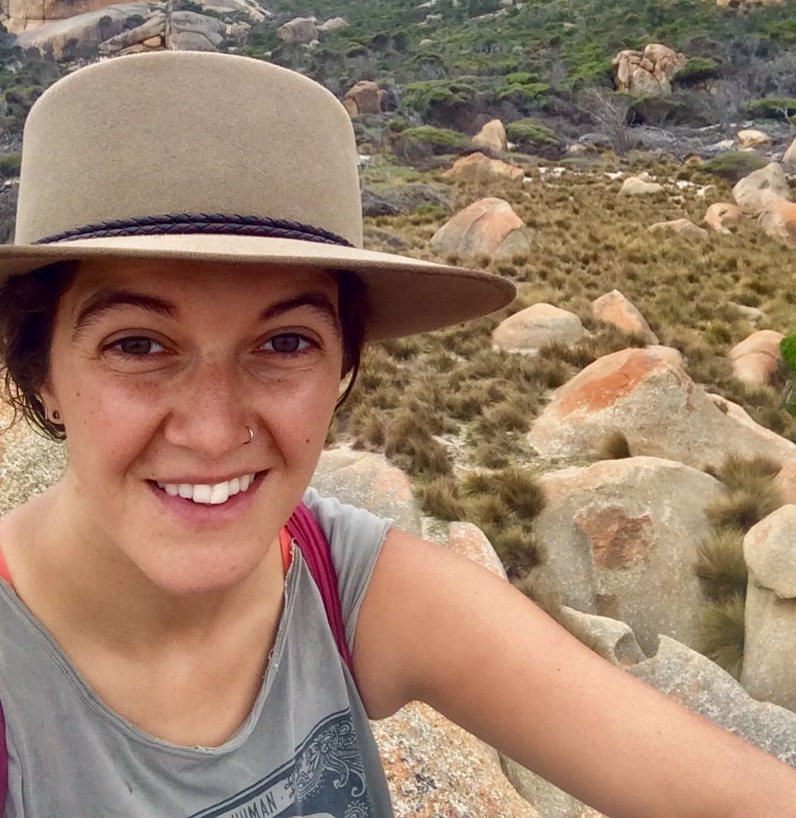
Kathy is from the small town of Yolla on the north-west coast of Tasmania. She is in the final year of her Ph.D. at the University of Tasmania’s School of Social Sciences, in partnership with CSIRO, the Centre for Marine Socioecology and the National Environmental Science Programme (NESP) Marine Biodiversity Hub. Kathy’s current research examines the success of local government waste management strategies in reducing waste from entering the coastal and marine environment. During her Ph.D. program Kathy ran marine debris workshops at the Faculty of Marine Sciences and Fisheries, Udayana University, Bali and several Tasmanian primary and secondary schools. Prior to commencing a Ph.D. Kathy worked on cool-temperature reef systems, southern Bluefin tuna populations and microplastics in marine sediments.

Presentation title: The success of getting consumers to reduce, reuse and refill bottled water?
It is estimated that one million plastic bottles are consumed globally every minute. Bottled water is one sector of the plastic bottle industry that has had rampant growth over the past years. Unfortunately, this consumption of bottle water is coupled with the subsequent littering of bottles by consumers. The carbon emissions generated from bottled water manufacturing alongside bottle litter causes harmful effects on the environment and wildlife. To reduce the harms of bottled water government and non-government organisations have implemented a range of strategies targeting bottled water consumption and its subsequent litter. For example, implementing bottle bans to reduce plastic bottle usage, promoting the benefits of re-using durable drink bottles and providing filtered water stations to refill bottles. Our study analyses the success of one of these strategies, a water refill station, implemented by an environmental organisation along the Brisbane River, Australia. Our study found plastic bottle litter in the Brisbane River did decrease after a water refill station was implemented. However due to choices in survey design and refill station location, we believe the behaviour change strategy did not reach its full potential. We highlight and discuss the factors an organisation needs to consider when designing a behaviour change strategy.
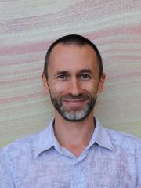
Dr Artem Golev, Sustainable Minerals Institute, University of Queensland
Dr Artem Golev is a Research Fellow at the Sustainable Minerals Institute, The University of Queensland. Having a multidisciplinary background in Economics, Engineering and Environmental Science, and over 15 years’ experience in the minerals industry and academia, his major research focus is on Industrial Ecology and Circular Economy in metal mining and recycling.
Presentation title: Metal flows and recovery of metals from urban and mine
Australia generates significant urban waste and enormous amounts of mine waste every year. While being different in nature and content, both waste streams have a potential for higher metal recovery, driven by a complex set of environmental, economic and regulatory factors. This presentation will overview metal use and circulation in the Australian economy, highlighting some opportunities for capturing additional value from waste. In the mining sector, combining waste reprocessing and metal recovery with better practices in mined land rehabilitation is potentially one way to unlock the value of waste, addressing both environmental and economic concerns.

Dr Anita Parbhakar-Fox, Sustainable Minerals Institute, University of Queensland
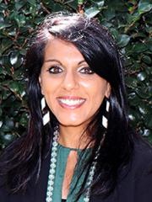
Dr Anita Parbhakar-Fox is a Senior Research Fellow in Geometallurgy and Applied Geochemistry at the W.H Bryan Mining and Geology Research Centre within the Sustainable Minerals Institute at the University of Queensland. Her research is focussed on mine waste characterisation to improve mine planning and waste management practices where she has worked with mining industry, METS sector and government stakeholders. She has developed new tests and protocols for improving waste characterisation and is also involved in identifying remediation options for abandoned/ historical mine sites. Most recently, Dr Parbhakar-Fox has led industry and government funded projects characterising a range of mine waste materials to evaluate their economic potential.
Presentation title: Mine waste as an economic prospect
In Australia there are reported to be 50,000+ abandoned mine sites with a significant proportion of these in need for rehabilitation to reduce the environmental risks posed to the neighbouring environments by the contained mine waste. But, have governments and mine operators been overlooking the economic potential of these wastes? Instead of focussing on treating the acid and metalliferous drainage emanating from these wastes or reducing the quantity of potentially hazardous dusts generated when these waste materials are left uncovered should we instead be looking at these sites as the next generation of ore deposits? In Tasmania, we have adopted a geometallurgical approach to charactering mine waste deposits. Through our investigations we have identified potential deposits of critical metals including cobalt and indium. By developing a workflow that allows for the efficient assessment of recommercialisation potential more tangible rehabilitation opportunities for Australia’s mine waste sites are presented with significant socio-environmental benefits to be gained.
Assoc Prof Majorie Valix, University of Sydney
Marjorie Valix is an A/Professor at the School of Chemical and Biomolecular Engineering at the University of Sydney and the Associate Dean (Courses) in the Faculty of Engineering. Her research interest are in bio-hydro processing of minerals and wastes, waste valorization, adsorption and biocorrosion. Her research has been recognised by International Water Association (IWA) Project Innovation Award in Applied Research at the Global and Regional Asia Pacific levels and B/HERT Awards. She is leading the wastewater section group in the Cooperative Research Centre Program for Smart Lining for Pipes and Infrastructure.
Presentation title: Integrated Approach in Recycling of Electronic Wastes
The build-up of electronic waste is an emerging problem globally but is more acute for developing countries. Without the systems and the technology in place to effectively capture and manage these wastes, the accumulation of e-wastes has become a pervasive problem at a local, regional and national level. The problem with e-waste is not just its growing volume but also its toxicity, and its content of valuable resources (e.g., gold, copper) which are lost when e-waste is disposed. The issue is that e-wastes are heterogeneous constituting of glass, metal and plastics. To make it worse they also contain toxic components such as brominated flame retardant, lead and mercury that currently makes the waste extremely challenging to re-process. The development of universally acceptable technology for managing e-waste is still evolving. This paper presents an integrated technology that exploits the natural ability of microorganisms to extract the metallic fractions by bioleaching and the biohydropyrolysis of the plastic components of the e-waste.

Andrew MacKenzie, Envirostream
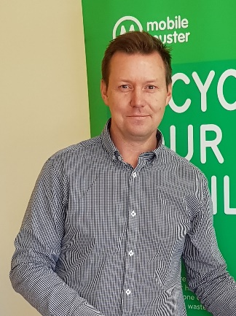
Andrew Mackenzie is the founder and director of Envirostream Australia Pty Ltd and the director of PF Metals Pty Ltd, with over 20 years industrial processing and manufacturing experience. Currently, as the director of two resource recovery companies; Andrew overseas operation which are primarily focused on maximising ferrous and non-ferrous metal recovery at PF Metals, and Australia’s first lithium, alkaline and nickel metal hydride battery processor, Envirostream Australia. Andrew spent over two years researching and prototyping the processing equipment before Envirostream began its operations in early 2017 with the vision of increasing the low battery recycling rate in Australia through continuous innovation and on-shore processing capacity. Previously, Andrew owned and operated an industrial machinery manufacturing business. The range of machines built where for manufacturing in a range of industries from food processing, woodworking and steel fabrication. This has given Andrew a strength in a wide range of processes that can be applied in unique ways to current and future projects. Andrew also travels to all the downstream partners to ensure best practice is constant and innovation discussions continue in processing, quality and end market developments for the products in which his companies produce.
Presentation title: The challenges of recycling batteries in Australia
Jonovan Van Yken, CSIRO Land and Water/Murdoch University
Jonovan graduated from the University of Western Australia with a Bachelor of Science in Microbiology and Immunology. He completed his Honours at the Institute for Immunology and Infectious Disease at Murdoch University, specialising in Molecular Biology. Jonovan is currently completing a PhD at Murdoch University in conjunction with CSIRO, focussed on the recovery of metals from electronic waste using a combination of biohydrometallurgy and hydometallurgy approaches.
Presentation title: An integrated biohydrometallurgical process for metal recovery from electronic wastes
The treatment and recycling of electronic waste (e-waste) is an increasing waste management issue with global consequences. It is estimated that globally approximately 20–50 million tonnes of e-waste is generated annually, with a growth rate of 3-5% per annum. In Australia the majority of the unrecycled waste is sent to landfill. This contributes to 70% of the toxic chemicals in landfill, representing a large source of land and water contamination. E-waste is considered an important secondary resource because of its high metal content, and subsequent value. In 2014, the value of e-waste in Australia was estimated at US$370 M, with waste printed circuit boards (PCBs) accounting for US$150 M. With declining global mineral resources, recovering these metal values from e-waste is becoming increasingly attractive. Currently, no economically feasible technology is available to facilitate metal recovery in Australia. The geographical distribution of Australia’s population centres is a significant economical hurdle in the treatment of e-waste due to the high cost associated with transportation. This project aims to develop an integrated biohydrometallurgical process for the recovery of metals from PCBs. By using common biomining microbes Acidithiobacillus caldus, Leptospirillum ferriphilum and Alicyclobacillus disulfidooxidans to generate biogenic ferric iron and sulfuric acid it is possible to leach metals from PCBs. Once in a solution the metals can be recovered using biogenic hydrogen sulfate produced by sulfate reducing bacteria. The use of low-cost waste materials, such as waste organics and sulfur, as substrates for the growth of microorganisms is explored to reduce the operating costs. The modularity of the process will assist with meeting recycling demands for PCBs, and potentially other e-wastes, at various scales and in a manner that may allow for decentralised processing in the future.

Dr Daniel Roberts, CSIRO Energy
Daniel leads CSIRO's Hydrogen Energy Systems Future Science Platform. The Hydrogen FSP plays an important role in CSIRO's broad hydrogen RD&D program, by providing a strong scientific and technical foundation to CSIRO's work in enabling a renewable energy export industry based on hydrogen.
Before taking on the FSP role, Daniel led the High Efficiency Thermal and Electrochemical Technologies research group within CSIRO Energy. He continues to play a senior role in CSIRO’s gasification research activities, in particular thermochemical pathways for boienergy production from biomass and waste, and on behalf of Bioenergy Australia, he is the National Task Leader for IEA Bioenergy Task 36 “Material and Energy valorisation of waste in a Circular Economy”.
Presentation title: Waste-to-Energy Concepts in a Circular Economy
Australia lags behind the rest of the world in our uptake of thermal waste-to-energy systems, although there are now a number of projects at various stages of planning and development. Advanced waste-to-energy concepts, which are starting to gain traction globally, move beyond the production of just heat and power, and allow waste (and its embodied energy) to be used as a range of industrial and manufacturing feedstocks. This presentation discusses some of these approaches and gives some insights into their development and demonstration.
Kirthi deSilva, CSIRO Agriculture and Food
Kirthi De Silva completed his Bachelor of Science degree in Chemical Engineering with Honours at the University of Aston in Birmingham, UK. Kirthi joined CSIRO in 1992 and has researched on developing separation technologies for the food industry. Kirthi’s experience includes leading several projects developing cost-effective, scalable separation technologies at bench scale and scaling up the technology to pilot scale to manufacture value-added ingredients from food industry co-product streams. Kirthi’s experience ranges from developing and commercialising two applications of simulated moving bed chromatography (CSEP technology) to manufacture whey protein Isolate and a biofractions from cheese whey in the Victorian dairy industry, which was the worlds first commercial application of CSEP technology in the food industry, separation technology to fractionate seed meal co-product streams as functional ingredients, pilot scale technology to extract, separate, fractionate and concentrate high value functional ingredients from meat and horticulture processing co-product streams, to developing forward osmosis as a mild cost-effective dewatering technology for the food industry.
Presentation title: Turning food loss into innovative food and beverage products
The global population is expected to exceed nine billion by 2050. Food producers will face significant challenges to increasing food production in a challenging environment of climate change and constraints in resources to meet the needs of the growing population. Globally, food loss and waste (co-products) are significant where approximately one-third of food supply (over 1 billion tonnes) is lost from farm to fork. This loss is also a major waste of nutrients, and agricultural inputs of scarce resources such as land use, energy, fertiliser, and water. This loss also creates environmental issues such as in disposing of large volumes in landfill and contributing to greenhouse gas emissions. Australian food losses in grain, horticulture, meat, and seafood production were estimated at $2.9 billion in 2014-2015, where $1.8 billion was attributed to losses in horticulture. These losses are also significant lost opportunities for the food industry. In the food industry, significant wastage occurs on farm and in the value chain post-farm gate. Food losses and waste post-harvest include during sorting, packaging, processing, transport, distribution, retailing and consumption. There is potential to transform these food loss streams in the supply chain into new value-added ingredients, and food and beverage products. Researchers from the CSIRO have investigated and developed innovative technologies to process edible co-product streams into novel food and beverage ingredients and products.
Prof Bernadette McCabe, Centre for Agricultural Engineering, University of Southern Queensland
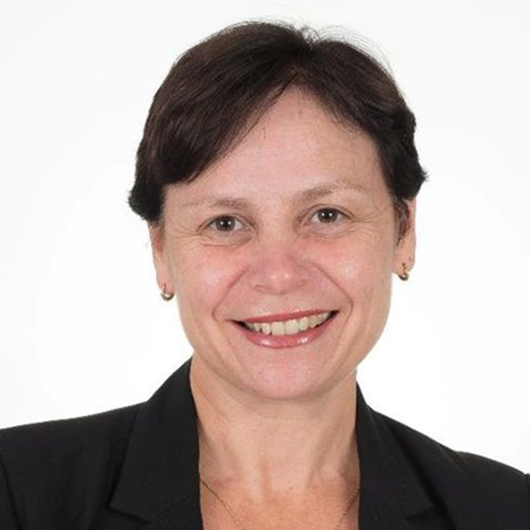
Professor Bernadette McCabe is a principal scientist at the University of Southern Queensland's (USQ) Centre for Agricultural Engineering (CAE) and is the Research Program Leader for Energy and Bioresource Recycling. Bernadette is Australia's National Team Leader for the International Energy Agency Bioenergy program Task 37: Energy from Biogas and is a Board Director at Bioenergy Australia. Bernadette has a background in agricultural biotechnology and has 20 years’ experience as an academic and researcher. Her research interest in energy capture, resource recovery of waste and biofertilisers has attracted over $3.0M in nationally competitive grants since 2010. Her research has been applied to the livestock, food processing and cropping sectors (both on and off farm) and water utilities. Bernadette extends her science communication beyond high impact journals by regularly contributing to media outlets to boost public awareness of bioenergy and has promoted science in schools since 2007 through CSIRO’s STEM Professionals in schools program.
Presentation title: Anaerobic Digestion of Food Waste for a Circular Economy
There is increasing awareness of the quantities of food that are lost every year across the globe; while the quality of available data varies, estimates suggest the total is around 1.3 billion tons. These losses occur at all stages of production, from pre-harvest on the farm through to post-harvest losses during processing, distribution, retailing and consumption. By far the largest proportion of this material is generated at the point of consumption, in the home or in cafeterias, canteens and restaurants. The method of choice to treat food waste is anaerobic digestion (AD) which is now undertaken commercially at a large scale internationally. It is most widespread in the UK, where there are currently 94 digesters producing over 220 MWe of power from food processing residues, supermarket wastes and curbside collected source-separated domestic food waste. These processes are efficient, with as much as 85% of the degradable material being turned into biogas. In order to use food waste in anaerobic digestion, it is preferable to separate food waste from other waste streams. Australia currently does not offer any schemes that support source separation of food waste. Notwithstanding this, there are upwards of five commercial scale plants currently treating food waste and substantial scope exists to increase this provided appropriate waste management strategies are put in place. This presentation will provide an international perspective of the role of AD of food waste in driving a circular economy and its potential growth for Australia in reducing the 4 million tonnes of food that reaches landfill each year.

Andrea Polson, Licella and iQRenew
Since 2015 Andrea has been Marketing and Communications Manager at Licella, the global leaders in hydrothermal upgrading, the process of chemically converting low value wastes and residues into higher value products. Alongside this, Andrea provides support to Licella’s business development team. Andrea is also Marketing and Communications Manager at iQ Renew, Australian commercial partner for the Cat-HTR platform and the first company in Australia to combine physical and chemical recycling. Prior to joining Licella, Andrea worked in a variety of sales, marketing and communication roles within the pharmaceutical and resources sectors. When she’s not running around after her two young children, Andrea is Marketing and Communications Consultant for Gelion Technologies, an Australian energy storage battery company. Andrea is passionate about supporting Australian technological innovation and hopes to inspire others to do the same.
Presentation title: Recycling More - Chemically recycling End-of-Life Plastic with the Cat-HTR platform
Currently only ~50% of plastic can be physically recycled, the rest ends up in landfill or the natural environment. Adding chemical recycling to resource recovery allows us to get closer to recycling 100% of plastics, enabling plastic to become a truly circular resource. Licella’s Cat-HTR platform is the most commercially advanced hydrothermal upgrading platform globally. Licella’s synthetic oil has a range of applications including more sustainable fuels, bitumen, waxes and chemicals, including those that can produce new plastics.
Dr Anna Littleboy, SMI, University of Queensland
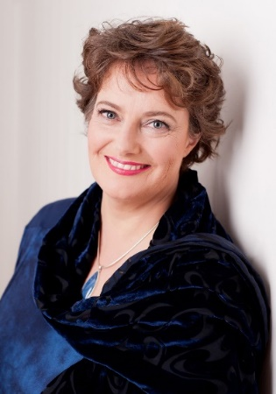
Anna is a Professor and Program Leader for Mine Lifecycle at the Sustainable Minerals Institute, the University of Queensland. She has shaped multidisciplinary initiatives linking social, environmental and technical performance for the energy resource sectors.
Originally a geochemist, Anna’s early career was spent in the lab and on site managing field programmes to characterise environmental risks from reactive contaminant transport and radioactive waste disposal. This catalysed an interest in understanding the role that technology and values play in decision making around industrial operations, regional impact and sustainability outcomes. Anna has worked on influential initiatives at the interface where science informs policy for a globally connected world. She has managed large collaborative programmes for Federal and State Governments, Industry and global think-tanks.
Presentation title: Wasting Innovation or Innovation in Wastes?: The challenges of delivering a circular economy.

Dr Erika Holt, VTT Finland
Dr. Erika Holt is a specialist in radioactive waste management and holds a PhD (2001, University of Washington, USA) in Civil Engineering. She has been a technical expert at VTT Technical Research Centre of Finland for 23 years, earlier as a Principal Scientist and then as a Research Team Leader. She has also served as the Program Manager of VTT’s program for Safe and Sustainable Nuclear Energy. She has been on the Finnish national governmental committee for the Nuclear Energy strategy (Vision2020, 2014) and served as an evaluator of European Commission research and development proposals.
Presentation title: Strive to be the Forerunner in Safe Radioactive Waste Handling and Storage
Dr. Holt will share insights about how Finland has advanced their radioactive waste management program to become a global leader by implementing the world’s first deep geological repository for permanent storage of waste. VTT has been supporting the Finnish industry and regulator to implement innovative solutions regarding the repository environment, materials, design, construction, monitoring and long-term safety. The interaction between science and various stakeholders has been key to maintaining the schedule and trust to advance the program, from which other countries can learn.

Dr Dirk Mallants, CSIRO Land and Water
Dr Mallants is senior principal research scientist at CSIRO Land and Water with a background in characterising and modelling water flow and contaminant transport in complex environments. He was previously overseeing safety assessments for the Belgian repository for high-level & low-level nuclear waste. He was also an IAEA expert involved with nuclear waste disposal in Eastern Europe, Asia, and South America. In Australia he has contributed to the South Australian Royal Commission into the Nuclear Fuel Cycle. He was subsequently hired as a subject matter expert for the NFC Consultation and Response Agency socialising the opportunities of expansion of the NFC in South Australia. He is currently developing the deep borehole disposal concept for disposal of intermediate level radioactive waste in Australia. Throughout his career he has always been an advocate for community participation in developing waste disposal solutions.
Presentation title: Nuclear waste recycling: from once-through to a closed fuel cycle.
Dr Christoph Gerber, CSIRO Land and Water
Dr Christoph Gerber is an environmental physicist and hydrogeologist with experience in isotope geochemistry, applications of noble gases in groundwater, and the development of new laboratory equipment. He has applied his experience to understand surface water – groundwater interactions, groundwater recharge processes and groundwater flow processes on a range of time scales and has developed new gear for field sampling. His research aims to understand and quantify groundwater flow processes as a basis to a more sustainable management of these resources. After a Bachelor and Master’s in Physics, Christoph did his doctoral studies at the University of Bern, Switzerland, where he used stable and radioactive isotopes of noble gases to date groundwater in several aquifers around the world. In September 2017, Christoph joined CSIRO as a senior experimental scientist in the Environmental Tracer and Applications Team. In his new role at CSIRO he has contributed to planning, fieldwork, laboratory analyses, interpretation, and reporting for several environmental tracer projects in Australia that aimed at assessing groundwater resources and their susceptibility to contamination in coastal, as well as in remote areas in the context of oil & gas projects (GISERA) or urban development.
Presentation title: Environmental tracers as a tool to assess possible release pathways associated with underground disposal of radioactive waste
For the long-term disposal of radioactive waste in underground geologic formations, it is crucial to understand potential pathways by which mobile radioactive elements may be transported from the disposal zone to nearby aquifers and to the surface (biosphere). Often, such transport would either take place through dissolution of radioactive elements in groundwater and subsequent advective transport via flowing groundwater, or through diffusion of dissolved elements through low-permeability formations (aquitards). Environmental tracers are a useful tool in determining if such underground pathways exist between a disposal zone and surrounding groundwater, and if so, what the timescales of advective or diffusive transport are. This presentation provides an overview of what environmental tracers are and how they are measured

Dr Nick Florin, Institute for Sustainable Futures, University of Technology
Dr Florin is a Research Director at the Institute for Sustainable Futures (ISF), University of Technology Sydney.
He manages the Resource Futures research group and directs and undertakes collaborative research projects with industry and government partners on resource conservation, recovery and recycling. His research involves policy options analysis, technology and infrastructure assessment, and stakeholder engagement to improve policy relevance, resource stewardship and supply chain sustainability.
Recently, he has advised the NSW Government on circular economy policy and led a major research project for the Australian Packaging Covenant Organisation that traced material flows through the waste management system and assessed resource recovery opportunities. Dr Florin has also partnered with Queensland and ACT governments, as well as the Australian Battery Recycling Initiative, on projects supporting the development of product stewardship for clean energy systems.
Presentation title: ‘Social and policy levers for transitioning to a circular economy’
Moving towards a circular economy is about changing the way we produce and consume products and services. Some changes are clear, such as phasing out problematic materials where there is an alternative, while other changes may require broad systemic intervention. Waste innovation is vital in supporting a circular economy, however broad success will come from coordinated system-wide change that requires social and policy change.
Sarah King, CSIRO Manufacturing
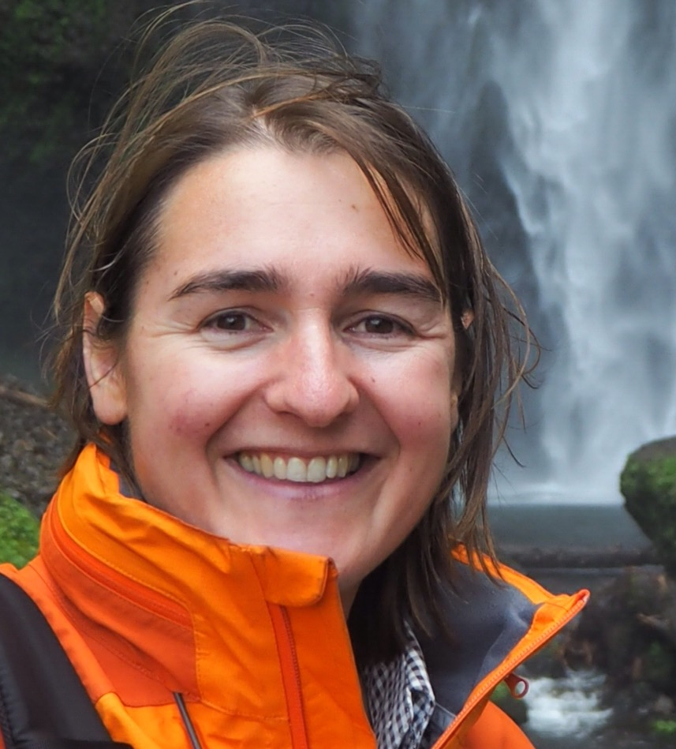
Sarah King is a senior research consultant working at CSIRO. Sarah’s research interests are innovation networks, industrial symbiosis and the circular economy. Sarah has authored reports at the intersection of science and innovation including; opportunities for Australian manufacturers in Asia; strategic innovation priorities for the Australian chemicals and plastics industry; Australian sustainable manufacturing priorities and recently, opportunities for lithium battery recycling in Australia. Sarah developed and delivered ASPIRE, an award winning, online matchmaking marketplace that helps SMEs divert waste from landfill, create new business to business collaboration and gain access to sustainable business networks. Sarah also led the highly successful pilot of Lean Launch Pad (LLP) into Australia through CSIRO. LLP is an entrepreneurial, start-up program for CSIRO researchers. Sarah was involved in designing, planning and facilitating LLP in Melbourne and Sydney, including recruiting CSIROs first external entrepreneurship mentors. Sarah has over 15 years’ experience working in the Manufacturing, R&D, Forestry, Agriculture and IT sectors. Sarah holds a Bachelor of Forestry Science from Canterbury University and a Masters in Corporate Environmental Sustainability Management from Monash University. Sarah is currently a PhD candidate at the University of Technology Swinburne, researching innovation networks, circular economy and sustainability transitions.
Presentation title: ASPIRE – Digital matchmaking for SMEs
ASPIRE (Advisory System for Processing, Innovation and Resource Exchange) is an online matchmaking marketplace. It is an Australian designed, web-based system for small to medium enterprises (SMEs). It was deployed in 2016 by CSIRO, with lead partner Kingston Council and in partnership with 3 other Melbourne local government regions. In 2017 it was expanded to Western Victoria through the Barwon South West Waste and Resource Recovery Group. ASPIRE captures data on business wastes and by-products to suggest business to business (B2B) collaborations and reduce waste to landfill. This concept is known as industrial symbiosis which engages traditionally diverse organisations in the physical exchange of waste materials and by-products. As a proactive, matchmaking waste exchange network it is likely to overcome problems experienced by passive waste exchange databases. The business model is dependent on digital and social innovation. It is unique in Australia and one of very few such projects in the world. This presentation will review what we learnt through that project, both success and failures. Also, how this project fits within a transition to a circular economy.

Hugo O’Connor, Data 61, CSIRO
Hugo O’Connor is a senior engineer with CSIRO’s D61. Prior to joining CSIRO, Hugo co-founded Bit Trade Australia in 2013, serving over 50,000 individuals and businesses, the oldest continually operating crypto-currency exchange in Australia. Bit Trade was instrumental in establishing The Australian Digital Commerce Association, an industry group with now over 80 members, driving the responsible adoption of blockchain technology by industry and governments across Australia to deliver innovation in all sectors of the economy. Hugo is passionate about the potential for applied cryptography to create positive social impact.
Presentation title: What can blockchain do for the circular economy?
This presentation will explore the potential uses of blockchain to support a circular economy.

Khairul Islam, CSIRO Mineral Resources/RMIT University/ BCSIR Bangladesh
Khairul has a metallurgical engineering background. At BCSIR Bangladesh, his research focused on the development and characterization of alloys for various applications. He developed a process for manufacturing Pb-free solder alloys to be used in electronics industries. Currently, he is pursuing a PhD degree on the recovery of metals from electronic waste at RMIT University in collaboration with CSIRO and Bangladesh Council of Scientific and Industrial Research (BCSIR) where he is also working as a Research Engineer.
Presentation title: Characterization of Bangladeshi waste mobile phone printed circuit boards and techno-economic evaluation of an e-waste recycling plant
The underdeveloped and inefficient processing and extraction of value from e-waste materials in Bangladesh is leading to the accumulation of waste materials and to environment problems of poor resource recovery, waste disposal issues and land and water contamination with hazardous elements. This presentation examines the economics of e-waste processing in Bangladesh through a proposed simple high temperature route where the valuable components are recovered in a copper-based metal alloy stream.

Angela Hoefnagels, DELWP, Victoria
Angela Hoefnagels is Manager of Waste and Resource Recovery at the Victorian Department of Environment, Land, Water and Planning. She is currently leading the development of a circular economy policy for Victoria. She has over 15 years of public policy experience and is a strong advocate for effective and efficient environment policies. Prior to her role in the Department, Angela led reviews of Australian and international policies and action on climate change for the Climate Change Authority and provided advice to the Australian Government. Angela holds a Bachelor of Arts and Bachelor of Laws from The Australian National University and a Master of Public Policy and Management from the University of Melbourne.
Presentation title: A circular economy policy and action plan for Victoria
Pressures on Victoria’s waste and resource recovery system are growing along with community expectations about waste reduction, better recycling and safe waste management. This provides an opportunity to rethink the way we produce, consume and dispose of finite resources in Victoria. The Victorian Government is developing a circular economy policy and action plan, which will provide a long-term vision and specific actions that will help Victorian businesses and communities achieve environmental, economic and social benefits. In a circular economy the environmental impacts of production and consumption are reduced, resource productivity is increased, and there are economic benefits for businesses. In a circular economy, consumers use products efficiently and minimise waste. This presentation will outline the government’s initial position on a Victorian circular economy and highlight some of the opportunities and issues identified for our state. In addition, the presentation will explore possible actions that government might take to support the transition to a more circular economy in Victoria.

Vaughan Levitzke, Green Industries, SA
Vaughan Levitzke has played a leading role in sustainability in South Australia for decades. He heads Green Industries South Australia (GISA). Prior to his role at GISA, Vaughan established, and led another ground-breaking organisation, Zero Waste SA. He also spent a decade with the South Australian Environment Protection Authority, regulating the waste and recycling sector, litter strategy, waste strategy, container deposit legislation, eco-efficiency and industry sustainability, including the Expanded SA container deposit scheme in 2003. Vaughan introduced the Zero waste Act 2003, Plastic Bags Ban Act in 2009 and the Green industries Act in 2017. He developed three 5-year waste strategies, with the 4th currently under development. He also instituted the annual independent Recycling Activity Survey, guided SA Waste regulatory reform from 2014 to present, including bans from landfill, implemented Australia’s largest public trial of household food waste collection, commissioned and delivered SA’s Circular Economy landmark study and developed and administering SA’s China Sword response. Vaughan is currently overseeing discussion and policy development on Single Use plastics phaseout and developing business examples that demonstrate circular economy, and public education campaign Which Bin. He often provides advice on waste legislation and governance models for other states in Australia and internationally, is a member of the UN Centre for Regional Development IPLA Board and is a former member of numerous university advisory boards and former member of KESAB board, and is Ex-officio member of GISA Board and was awarded Public Service Medal in 2015 for outstanding service in waste management reform and policy.
Presentation title: Circular Economy in South Australia- a Short summary.
Vaughan will outline the need, activity in South Australia, describe some examples, identify gaps, and highlight problems to be solved going forward with CE.

Delegate information
Dr Albert Ardevol Grau  Research Scientist, Structural Biology  CSIRO Manufacturing  albert.ardevolgrau@csiro.au | Dr Artem Golev  Research Fellow, Centre for Mined Land and Rehabilitation, Sustainable Minerals Institute  University of Queensland  a.golev@uq.edu.au | Dr Roger Mulder  NMR Specialist, Molecular Interactions  CSIRO Manufacturing  roger.mulder@csiro.au
Magdalena Ball  Research Support Lead  ORICA  maggie.ball@orica.com | Rabeeh Golmohammadzadeh  PhD Student, Department of Chemical Engineering  Monash University  rabeeh.golmohammadzadeh@monash.edu | Dr Stephen Northey  Research Fellow, Department of Civil Engineering  Monash University  stephen.northey@monash.edu
Dr Simon Barry  Research Director, Analytics Research Program, Analytics and Decision Sciences  CSIRO Data 61  simon.barry@data61.csiro.au | Dr Elaine Govender-Optiz  Lecturer, Department of Chemical Engineering, Faculty of Engineering and the Built Environment  University of Cape Town, South Africa  El.Govender@uct.ac.za | Hugo O’Connor  Senior Engineer  Architecture, Analytics and Platforms team  Data61, CSIRO  hugo.o’connor@data61.csiro.au
Dr Johan Basuki  Research Scientist, Biomedical Polymer Chemistry  CSIRO Manufacturing  johan.basuki@csiro.au | Dr Nawshad Haque  Senior Research Scientist, Electrochemical Energy Systems  CSIRO Energy  nawshad.haque@csiro.au | Melanie Oke  Waste Management Coordinator  Sustainability Victoria  melanie.oke@sustainability.vic.gov.au
Dr Michael Batten  Senior Experimental Scientist, Applied Porous Materials Team  CSIRO Manufacturing  michael.batten@csiro.au | Danielle Hewitt  Experimental Scientist and Technology Transfer Advisor  CSIRO Mineral Resource  danielle.hewitt@csiro.au | Dr Anita Parbhakar-Fox  Senior Research Fellow, Mining and Geology Research Centre, Sustainable Minerals Institute  University of Queensland  a.parbhakarfox@uq.edu.au
Dr Tim Baynes  Senior Research Scientist, Sustainable Consumption & Production  CSIRO Land and Water  tim.baynes@csiro.au | Angela Hoefnagels  Manager of Waste and Resource Recovery  Department of Environment, Land, Water and Planning, Victoria  angela.hoefnagels@delwp.vic.gov.au | John Phalen  Chief Research Consultant  CSIRO Land and Water  john.phalen@csiro.au
Dr Anand Bhatt  Team Leader, Electrochemical Energy Storage  CSIRO Energy  anand.bhatt@csiro.au | Dr Erika Holt  Customer Account Lead  VTT Energy, Finland  erika.holt@vtt.fi | Andrea Polsen  Marketing and Communications Manager  Licella Pty Ltd  andrea.polsen@licella.com
Dr Naomi Boxall  Research Scientist, Environmental and Industrial Biotechnology  CSIRO Land & Water  naomi.boxall@csiro.au | Filip Janakievski  Team Leader, Bioproducts Supply Chain  CSIRO Agriculture and Food  filip.janakievski@csiro.au | Dr Markus Reuter  Director  Helmholtz-Zentrum Dresden-Rossendorf, Germany  a.begenau@hzdr.de
Dr Pete Cass  Senior Research Scientist, Biomedical Polymer Chemistry  CSIRO Manufacturing  pete.cass@csiro.au | Dr Anna Kaksonen  Group Leader, Biotechnology and Synthetic Biology  CSIRO Land & Water  anna.kaksonen@csiro.au | Dr Daniel Roberts  Leader, Hydrogen Energy Systems Future Science Platform  CSIRO Energy  daniel.roberts@csiro.au
Lesley Clementson  Group Leader, Temperate Coastal  CSIRO Oceans and Atmopsheres  lesley.clementson@csiro.au | Dr Joerg Kleeberg  Research Group Leader, Material and Process Analysis  TU Bergakademie Freiberg, Germany  joerg.kleeberg@iec.tu-freiberg.de | Hayley Rolfe  Founder  Ardea Waste  hayley@ardeawaste.com
Dr Gavin Collis  Team Leade, Electrochemical Systems  CSIRO, Manufacturing  gavin.collis@csiro.au | Laurie Kozlovic  Chief Strategic Development and Innovation Officer  Veolia  chantelle.ianni@veolia.con | Prof Veena Sahajwalla  Director, Centre for Smart Materials Research and Technology (SMaRT)  University New South Wales  smartcentre@unsw.edu.au
Jake Davies  jakedavies@live.com | Vaughan Levitzke  Chief Executive  Green Industries, South Australia  vaughan.levitzke@sa.gov.au | Dr Heinz Schandl  Team Leader, Sustainable Consumption & Production  CSIRO Land and Water  heinz.schandl@csiro.au
Ian Davies  Hume City Council  iand@hume.vic.gov.au | Prof Anna Littleboy  Program Leader, Mine Lifecycle, Sustainable Minerals Institute  University of Queensland  a.littleboy@uq.edu.au | Charmaine Sevil  Foresight, Innovation, Design  Sevil Co.  charmaine@sevilco.com.au
Kirthi Desilva  Group Leader, Breakthrough Bioprocessing  CSIRO Agriculture and Food  kirthi.desilva@csiro.au | Dr Katherine Locock  Research Scientist, Organic Process Chemistry  CSIRO Manufacturing  katherine.locock@csiro.au | Lynette Smith  Founder, Managing Director  Gramma  lynsmith@gramma.com.au
Dr Noel Duffy  Team Leader, Photovoltaics Development  CSIRO Energy  noel.duffy@csiro.au | Gemma Londema  Business Development and Commercial Manager  CSIRO Land & Water  gemma.londema@csiro.au | Narendran Subramaniam  Co-Founder and CTO  Ardea Waste  narendran@ardeawaste.com.au
Dr Melisa Duque  Research Fellow, Emerging Technologies Research Lab  Monash University  melisa.duque@monash.edu | Andrew MacKenzie  Director  Envirostream  andrew@envirostream.com.au | Sean Trewick  Founder and Research Lead  Circular Citizen  sean@circularcitizen.com
Fiona Etherington  Schneider Electric  fiona.etherington@se.com | Dr Dirk Mallants  Senior Principle Research Scientist, Environmental Tracers & Applications  CSIRO Land & Water  dirk.mallants@csiro.au | A/Prof Marjorie Valix  Associate Dean  School of Chemical and Biomolecular Engineering  University of Sydney  marjorie.valix@sydney.edu.au
Damien Feneley  Principal  Grose View Public School  damien.feneley@det.nsw.edu.au | Cynthia Martin  Consultant  CSIRO Alumni Association  tin442@gmail.com | Jonovan Van Yken  PhD Student  CSIRO Land and Water  jonovan.vanyken@csiro.au
Natasha Flores  Industrial Officer, Unions NSW  nastasha.flores@industry.gov.au | Robert Matusewicz  Technical Development Manager  Outotec  robert.matusewicz@outotec.com | Luis Verdugo  Doctoral Researcher  Monash University  luis.verdugo@monash.edu
Dr Nick Florin  Research Director, Institute for Sustainable Futures  University of Technology Sydney  nick.florin@uts.edu.au | Prof Bernadette McCabe  Principle Scientist, Centre for Agricultural Engineering (Operations)  University of Southern Queensland  Bernadette.mccabe@usq.edu.au | Dr Andrea Walton  Social Scientist, Resources & Communities  CSIRO Land & Water  andrea.walton@csiro.au
Sandra Fox  Strategic Account Manager, Government  CSIRO  sandra.fox@csiro.au | Dr Kathie McGregor  Research Director, Processing  CSIRO Mineral Resources  kathie.mcgregor@csiro.au | Dr Mike Williams  Research Scientist, Emerging Contaminants & Risk  CSIRO Land and Water  mike.williams@csiro.au
Dr Christoph Gerber  Senior Experimental Scientist, Environmental Tracers & Applications  CSIRO Land and Water  christoph.gerber@csiro.au | Cameron McKenzie  Director  Aspire  camm@aspiresme.com | Kathy Willis  PhD Student  CSIRO Oceans and Atmospheres  kathy.willis@csiro.au
 | Mitch Morison  Principle  Morison Advisory  mitch@morisonadvisory.com | Natasha Wright  Group Leader, Biophysics  CSIRO Manufacturing  natasha.wright@csiro.au

CONTACT US  t 1300 363 400  +61 3 9545 2176  e csiroenquiries@csiro.au  w www.csiro.au  At CSIRO, we do the  extraordinary every day  We innovate for tomorrow and help improve today – for our customers, all Australians and the world.  Our innovations contribute billions of dollars to the Australian economy  every year. As the largest patent holder  in the nation, our vast wealth of intellectual property has led to more  than 150 spin-off companies.  With more than 5,000 experts and a burning desire to get things done, we are Australia’s catalyst for innovation.  CSIRO. WE IMAGINE. WE COLLABORATE.  WE INNOVATE. |  | For further information  Dr Naomi Boxall  CSIRO Land and Water  t +61 8 9333 6260  e naomi.boxall@csiro.au  w https://people.csiro.au/B/N/Naomi-Boxall

